Biomedical Department

Industrial Visit: GCS Medical College

Subject: | Human Biology-I
Date of Visit: | 14th November 2025
Number of Students: | 28
Accompanying Faculty: | Mrs. H. B. Parmar & Ms. M. P. Solanki

INTRODUCTION
To strengthen theoretical knowledge through practical exposure, the Biomedical Engineering Department organized an educational hospital visit for 1st semester students under the subject Human Biology-I. A total of 28 students, guided by two faculty members, reached GCS Medical College at 2:00 PM. The visit provided valuable insights into the Human Anatomy and Physiology departments, combining live demonstrations, expert lectures, and interactive discussions.
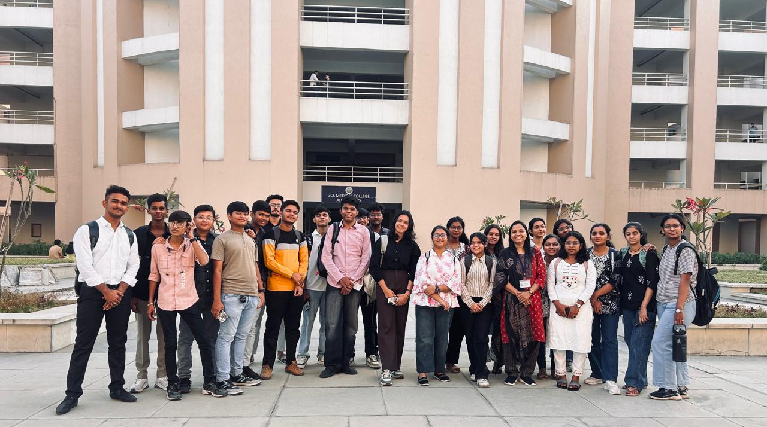

Anatomy Department (5th Floor)

The introductory session was conducted by Mr. Akshay Panchal, (Executive Corporate Development) where he shared basic information and explained the various facilities provided at GCS.

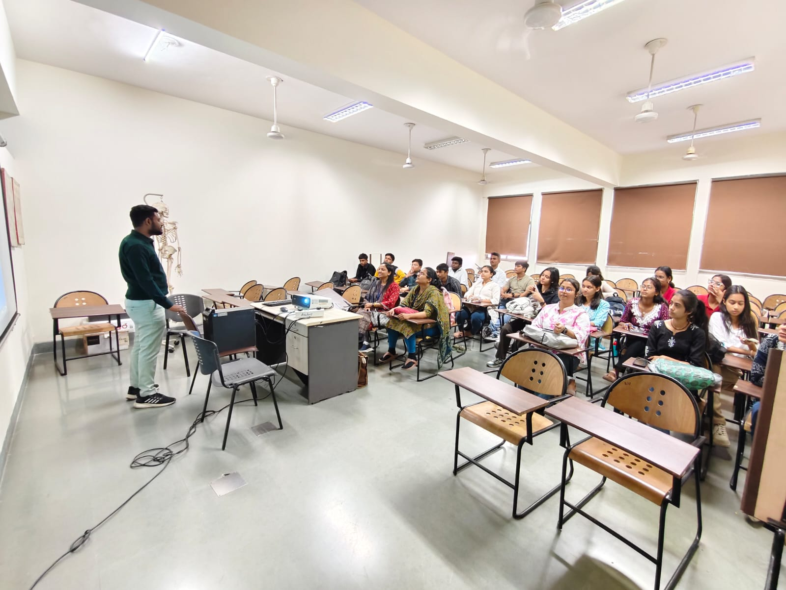

Demonstration Lecture by Dr. Nirav Patel (Prof. Anatomy Department)

The first session took place in the Anatomy Department located on the 5th floor. Students were escorted to a demonstration classroom equipped with anatomical charts, models, and a skeleton. Dr. Nirav Patel conducted a highly informative anatomical demonstration focused on cell biology and the skeletal system. Key highlights included:

a) Cell Structure and Organelles

Explanation of the fundamental concept of the cell as the basic unit of life.

The importance of each organelle in maintaining cellular physiology was explained.

b) Skeletal System Demonstration

Dr. Nirav Patel used a life-size human skeleton model to explain 206 bones of the adult human body
- Skull bones
- Vertebral column (cervical, thoracic, lumbar vertebrae)
- Ribs and sternum
- Upper and lower limb bones
- Pelvic and pectoral girdles
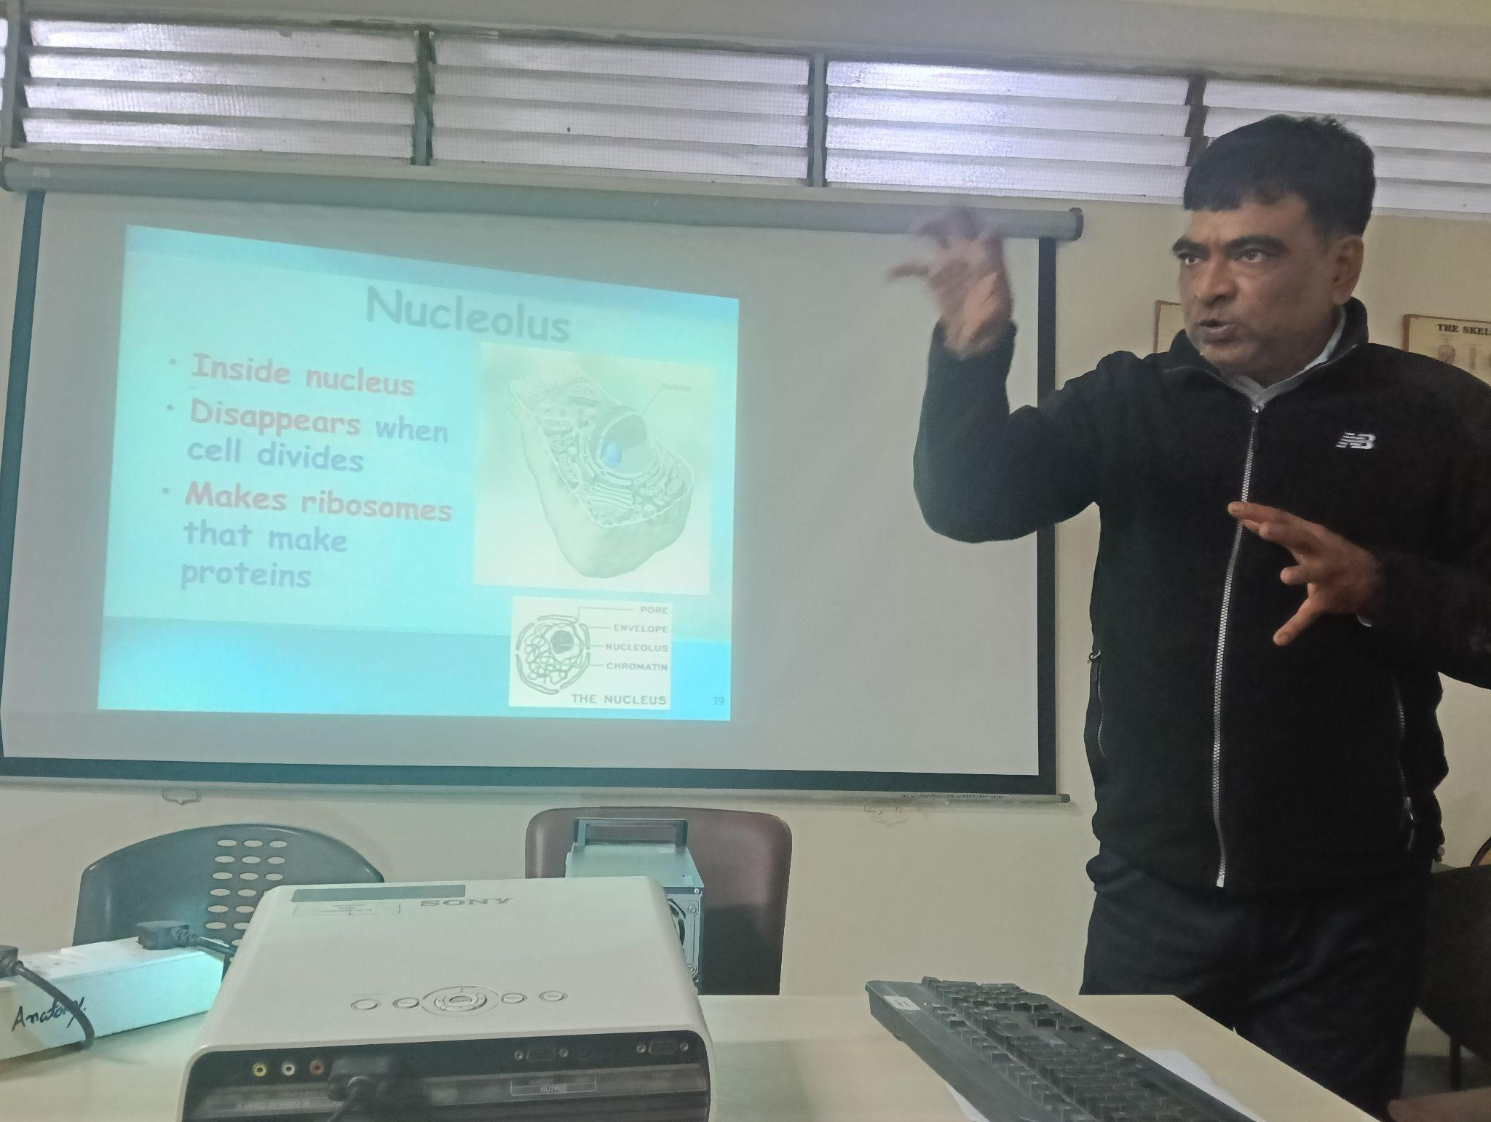 | 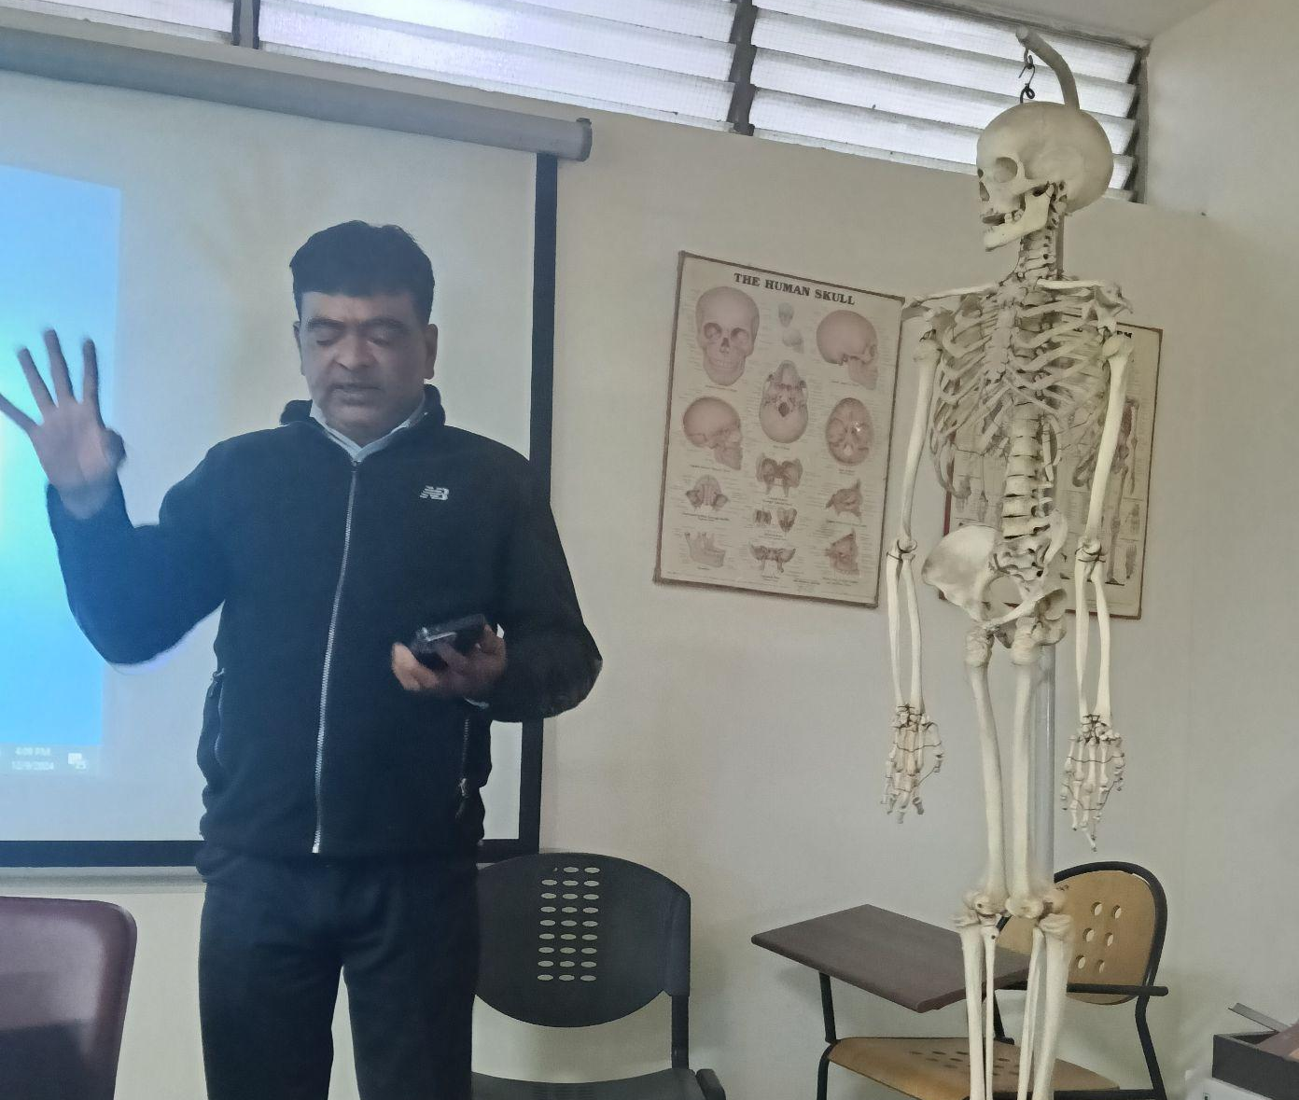
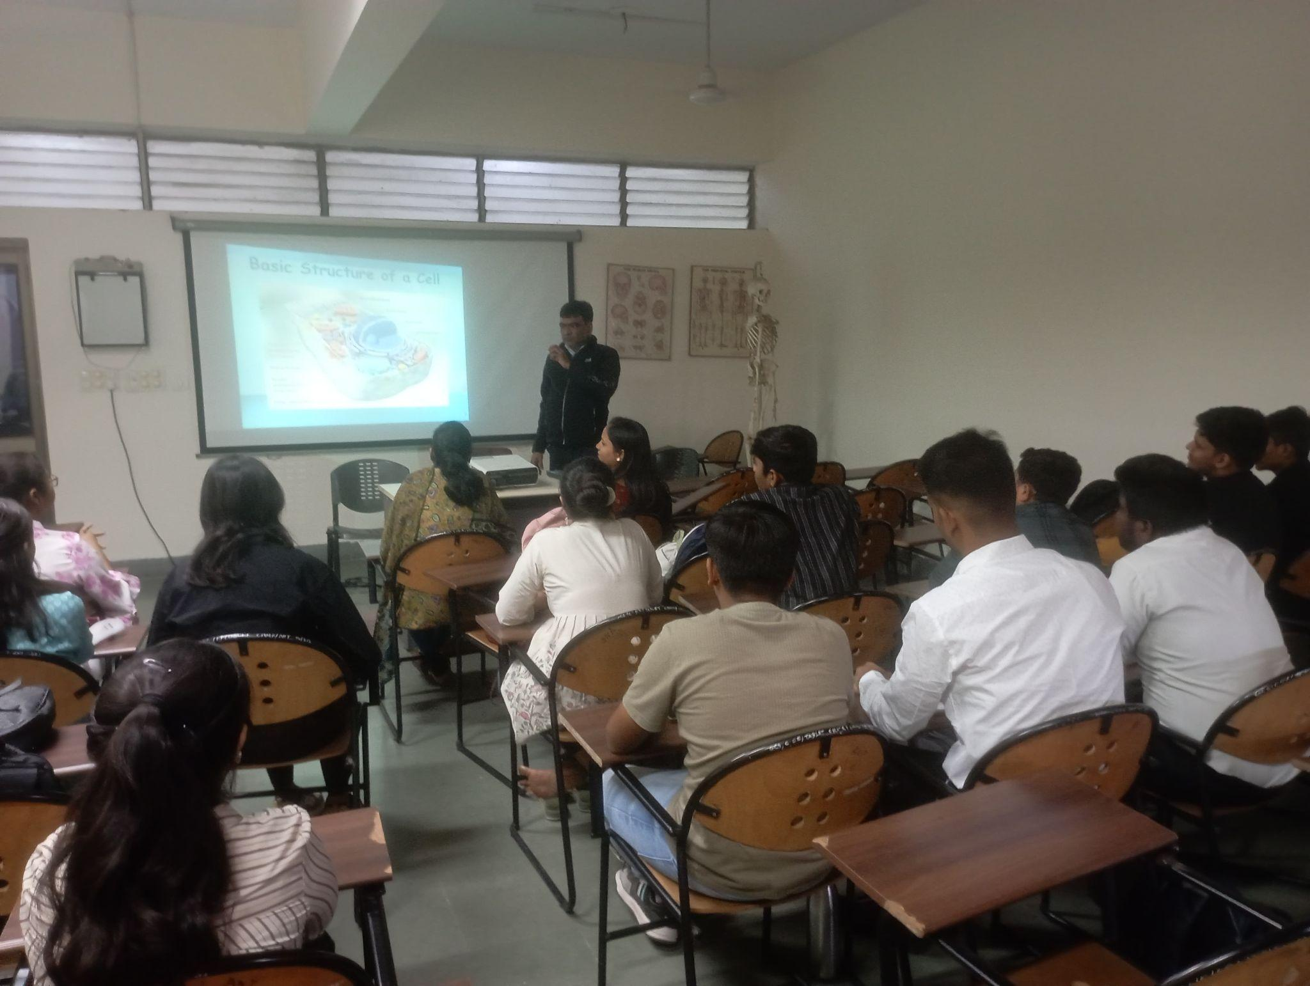

Visit to Anatomy Laboratory

After the lecture, students were taken to the Anatomy Laboratory, where real preserved specimens and cadavers used for medical education were displayed.

a) Cadaver Exposure

Many students, for the first time, saw:

Preserved dead bodies (cadavers)

Dissected organs

This created curiosity and also helped them understand the importance of cadaveric study in medical science.

b) Demonstration of Human Heart

Students observed a preserved human heart specimen.
Key aspects explained:

Four chambers: right/left atrium, right/left ventricle

Valves: tricuspid, bicuspid (mitral), and semilunar valves

Major blood vessels entering and leaving the heart

C) Lungs Model

A demonstration of the lungs model included:

Lobes of right and left lungs

Bronchial tree structure

Gas exchange surfaces

Students gained clear insight into how respiratory organs function in real life.

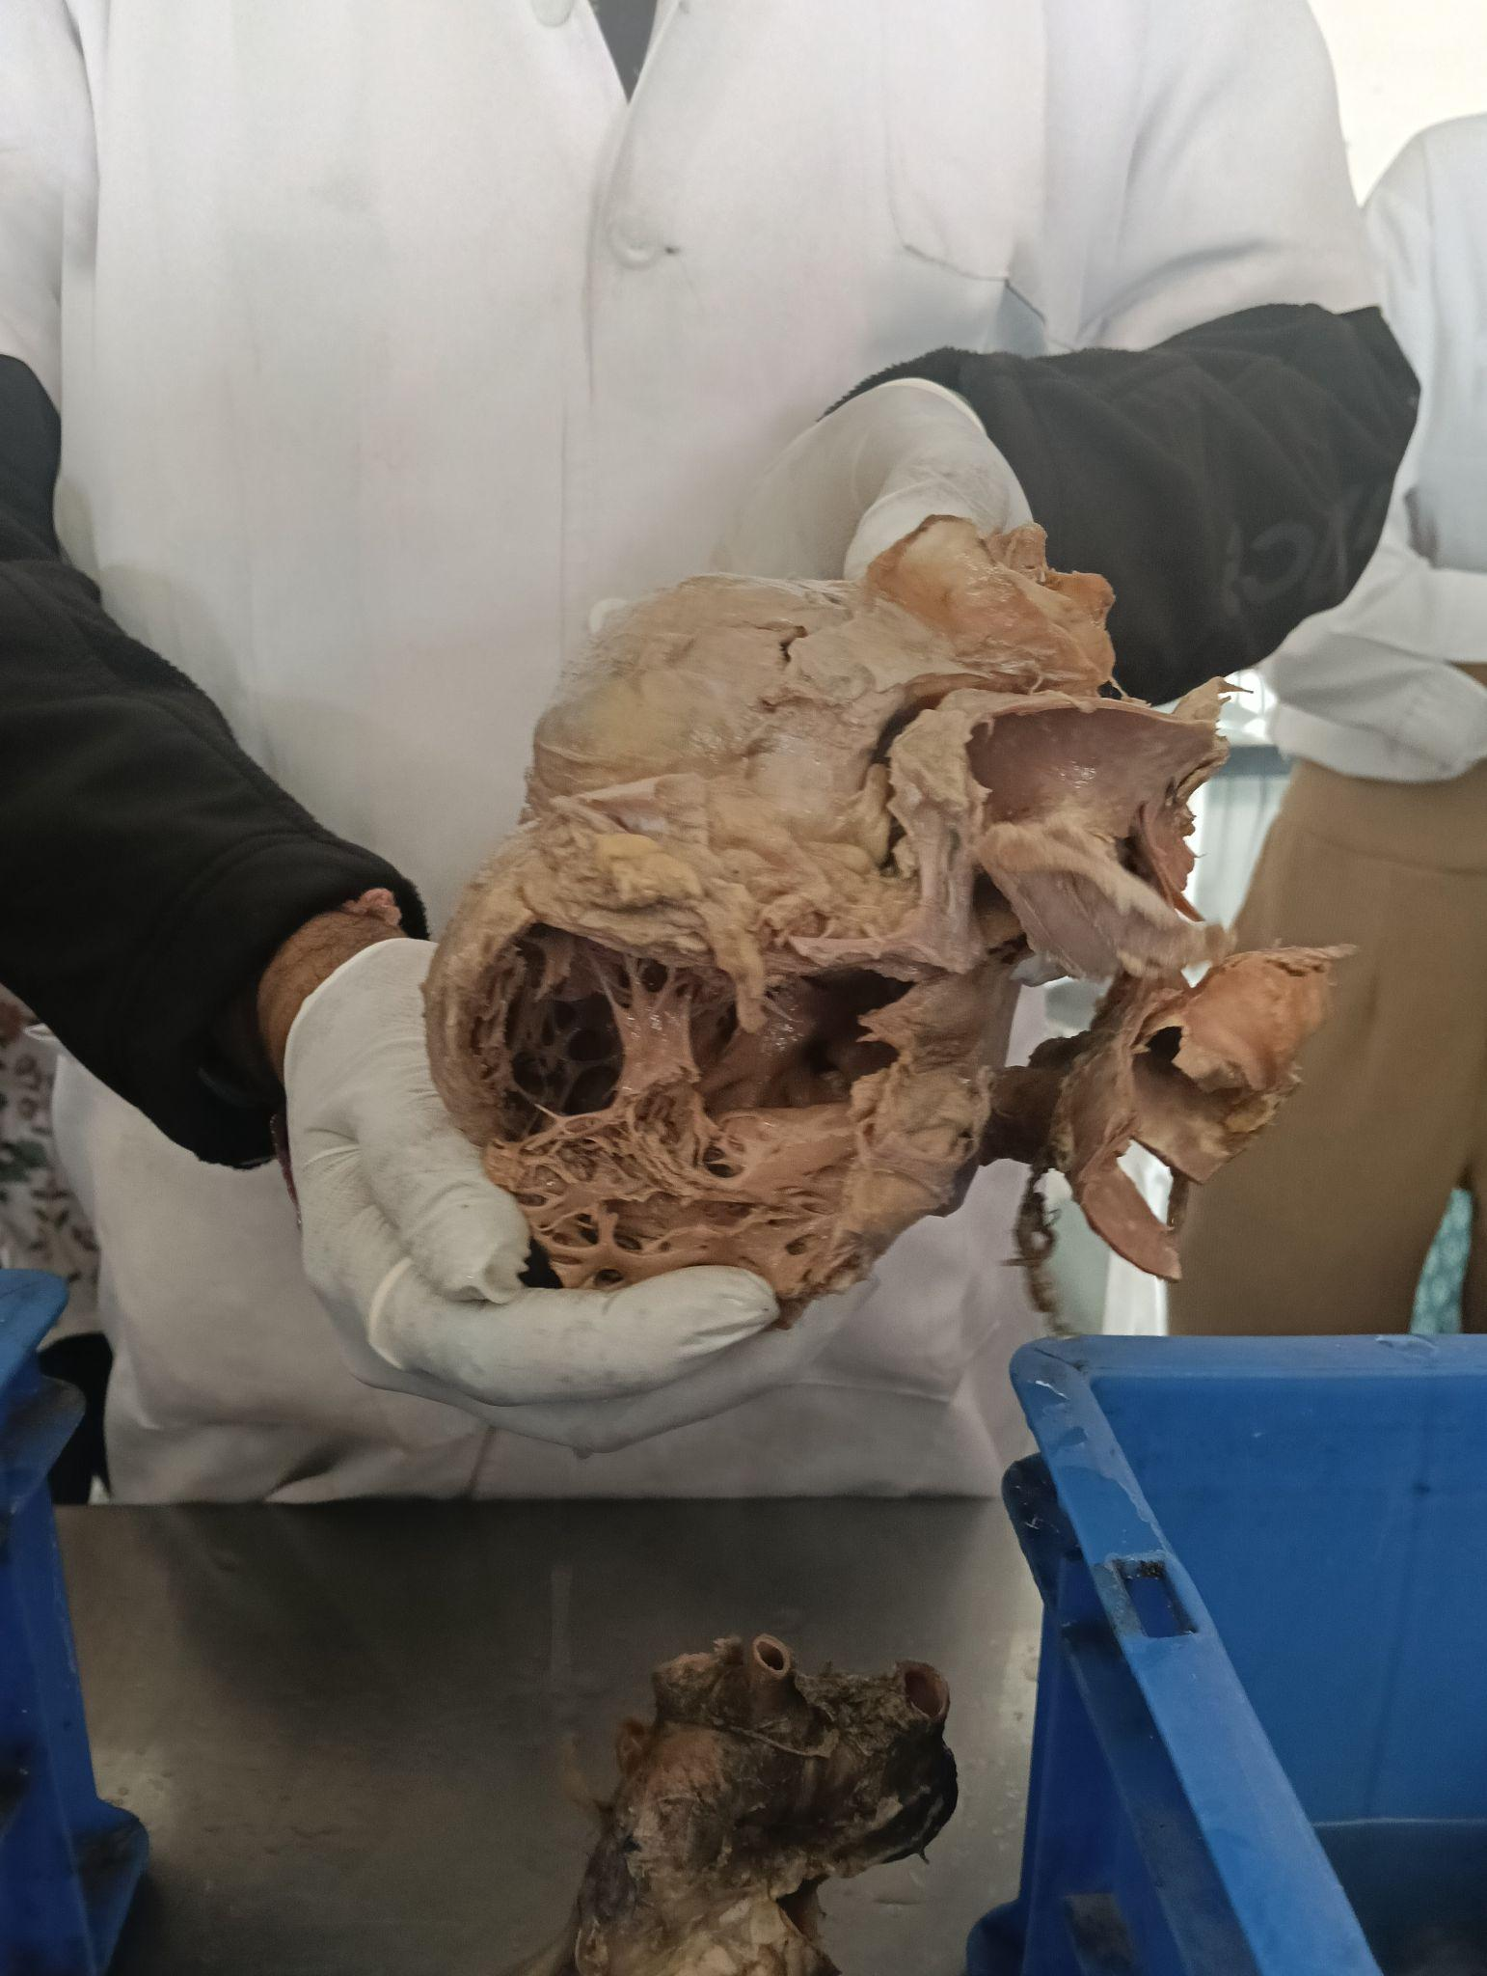 | 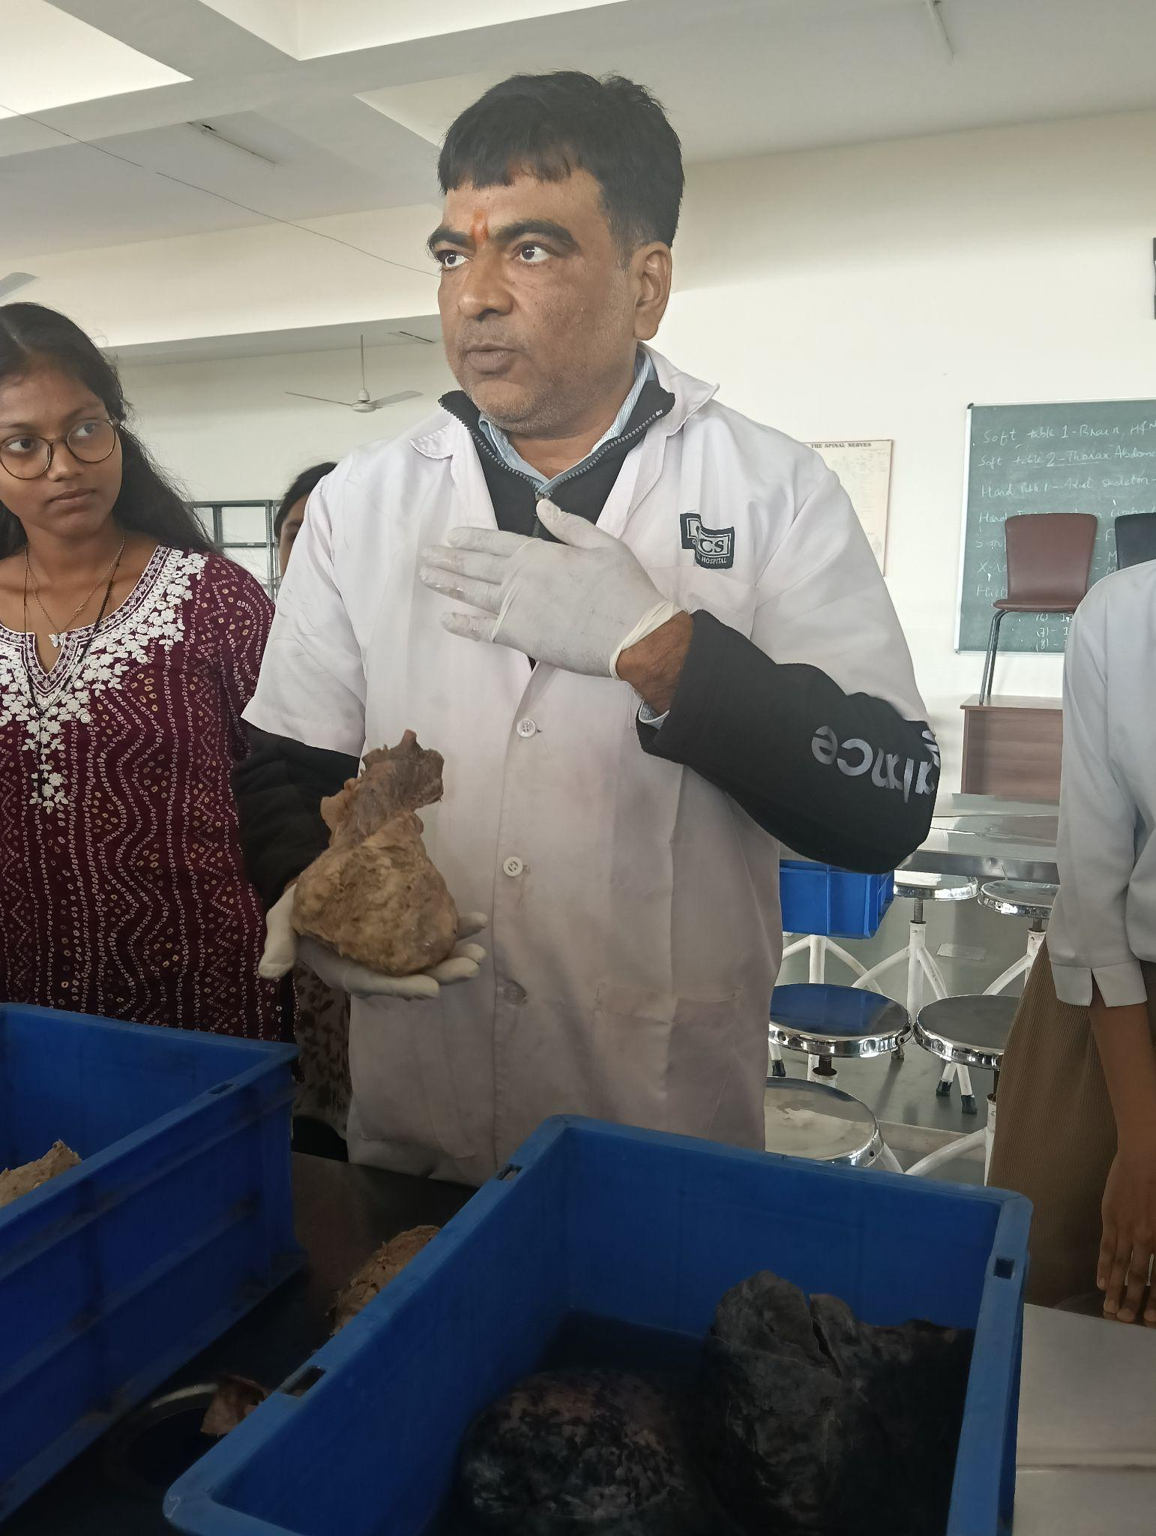
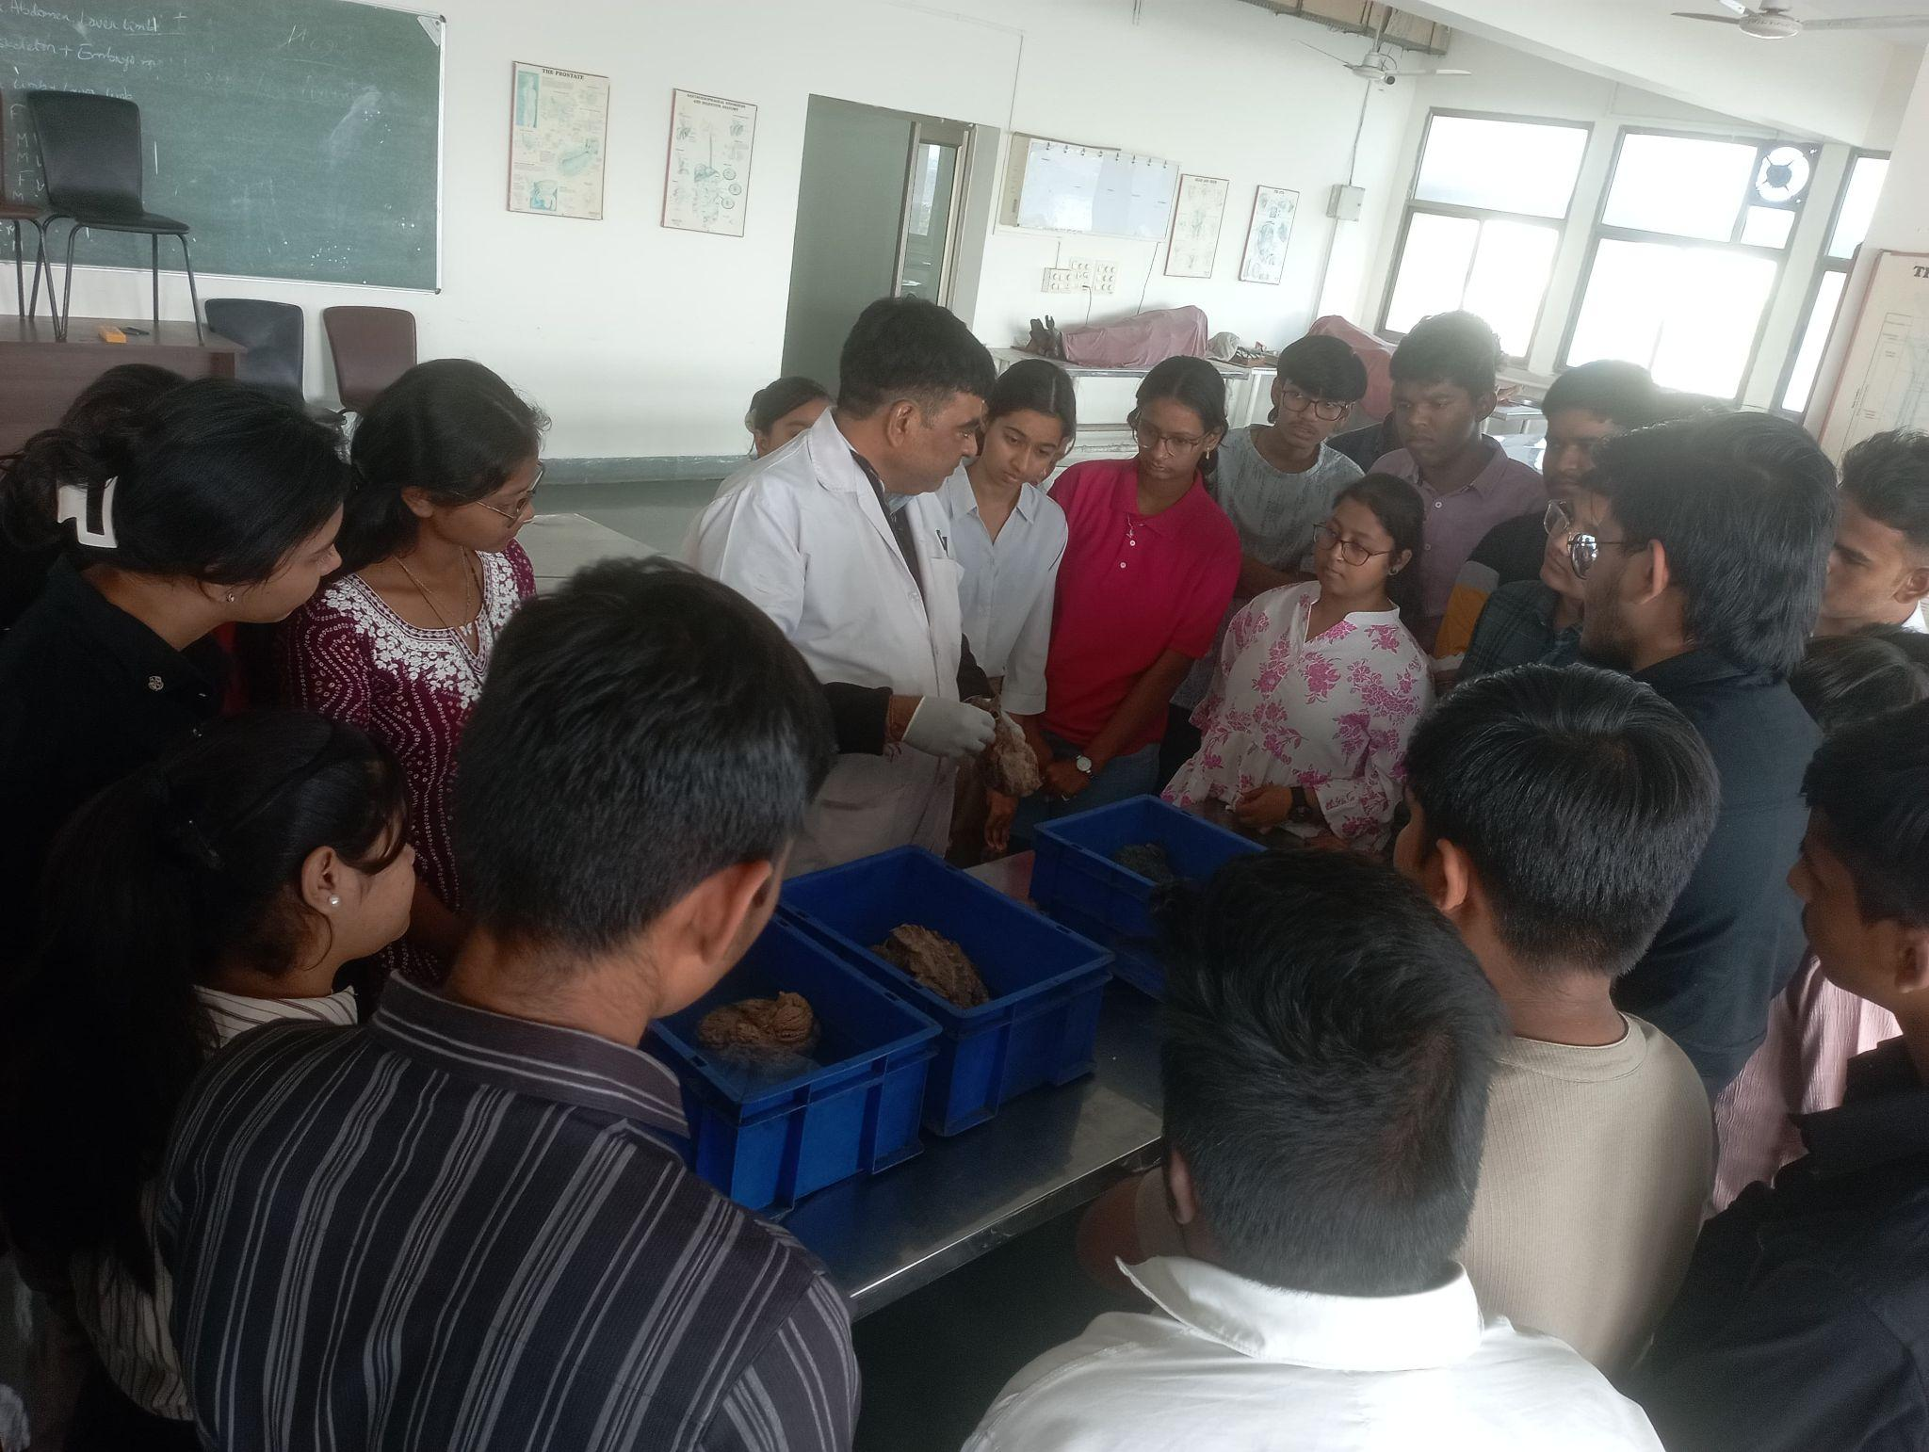 | 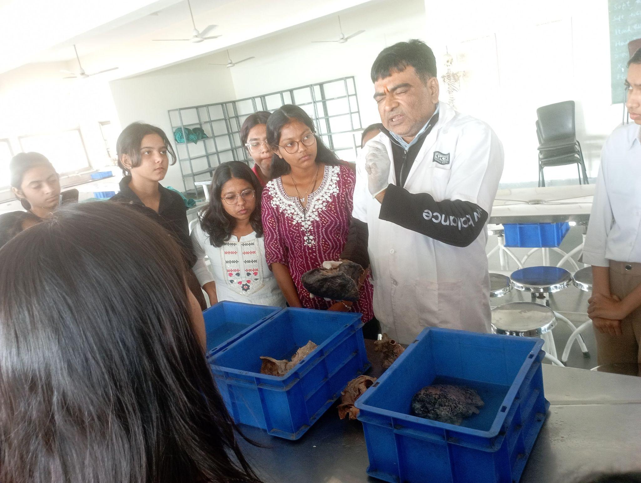
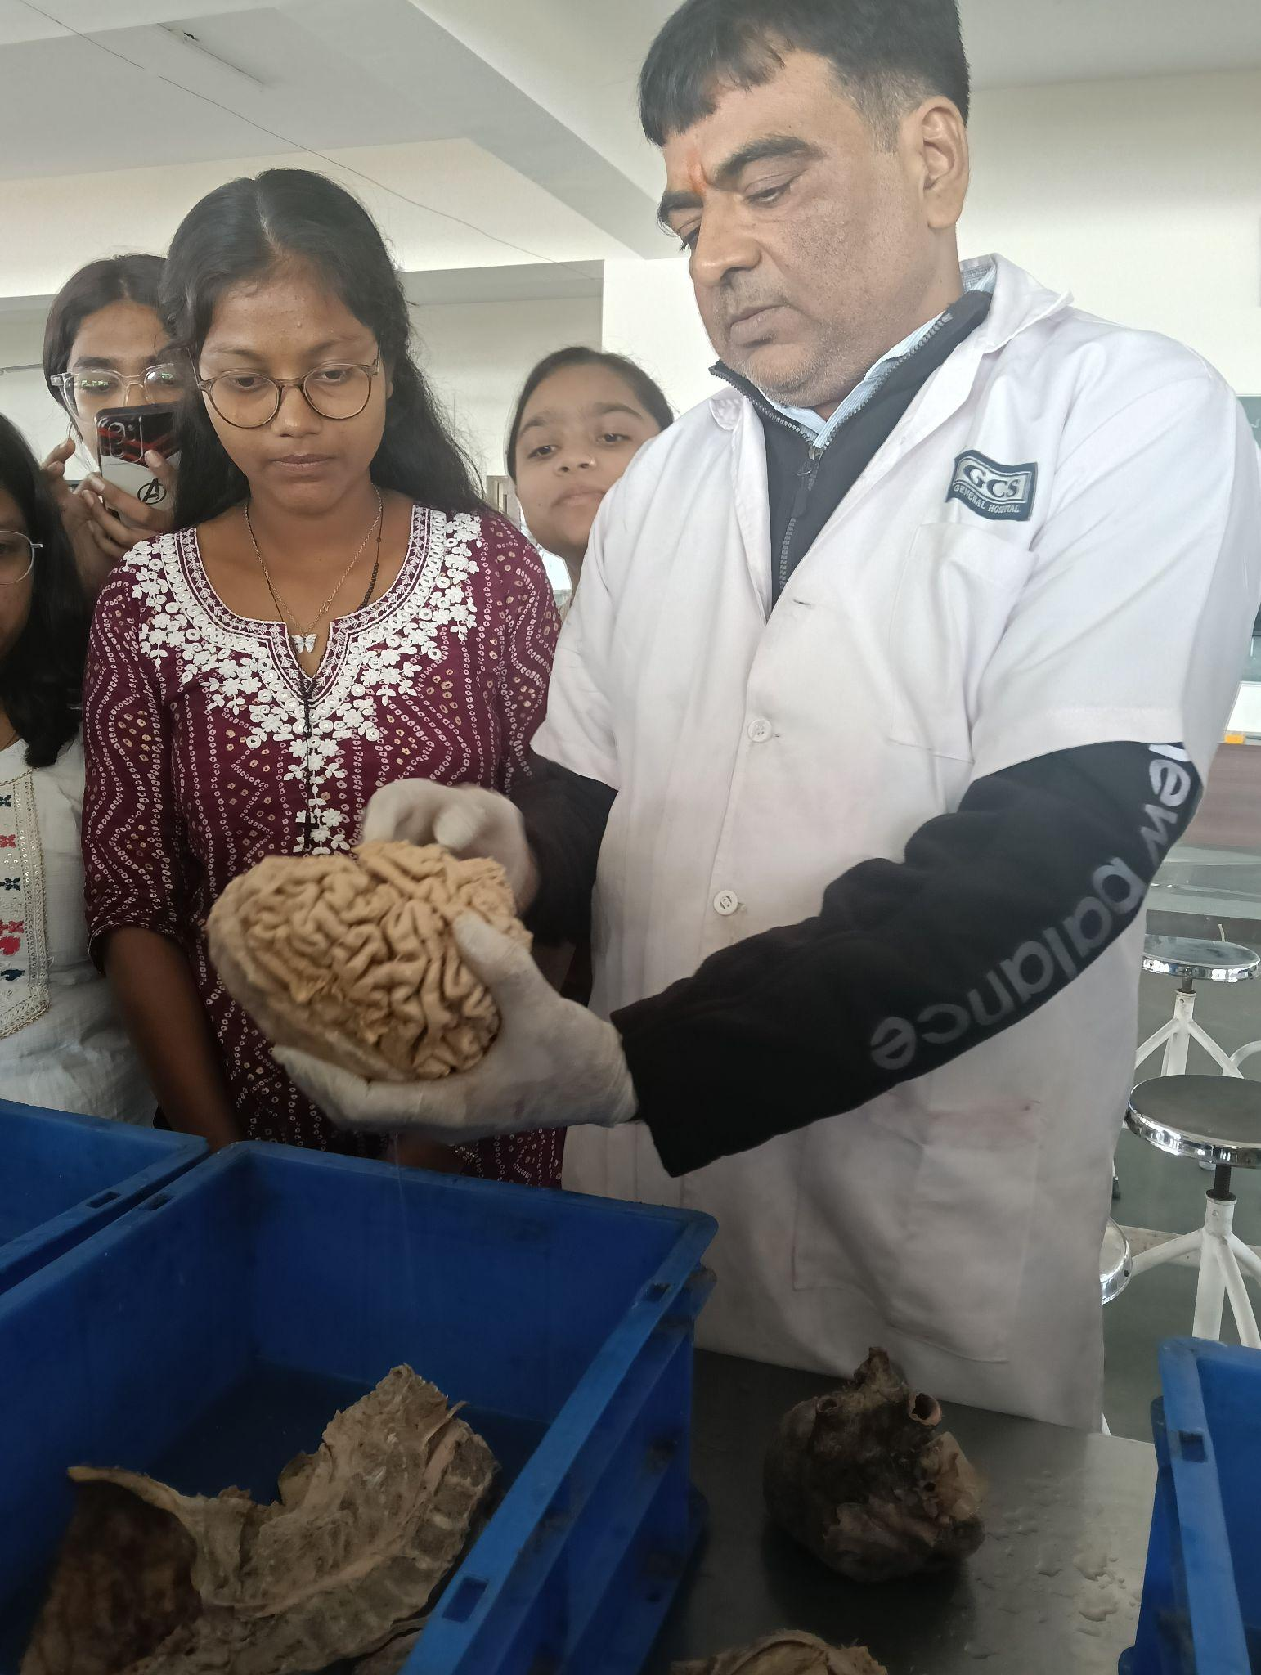 | 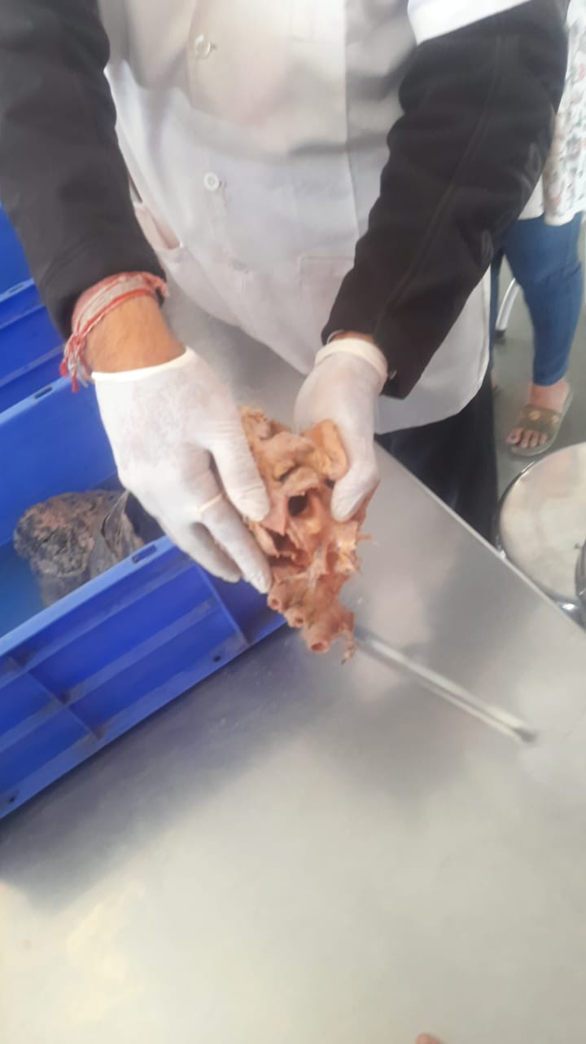
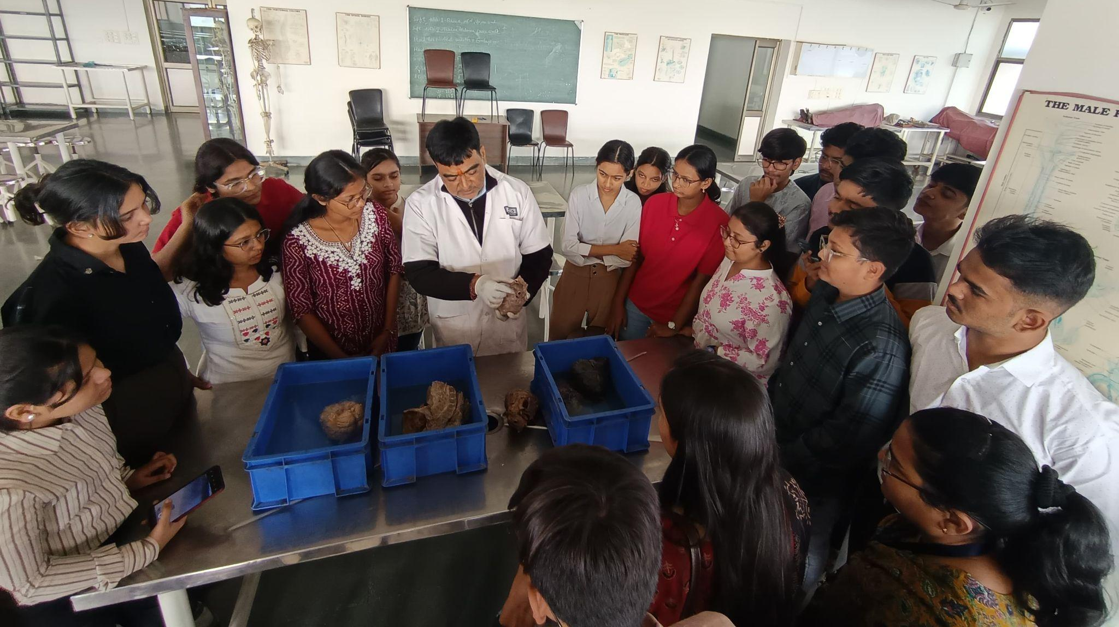

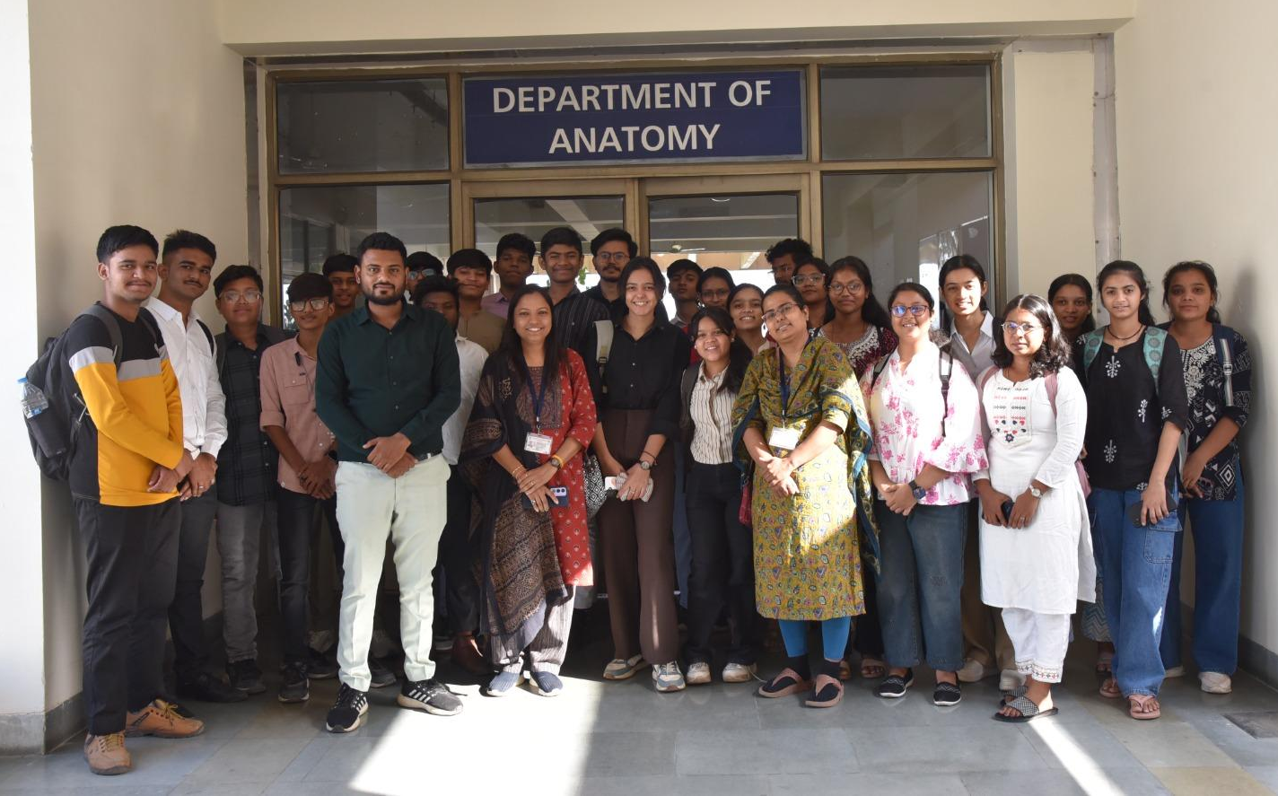

Visit to Physiology Department

Around 3:15 PM, the group moved to the Physiology Laboratory, where Dr. Ritu Bhati, Professor Physiology welcomed and guided them through instruments and models used in physiological assessment.

Physiological Instruments Demonstrated

Dr. Ritu Bhati, explained in detail the working principles and applications of the following:

a) TMT (Treadmill Test) Machine

b) Spirometer

c) Incubator

d) Anatomical Models

Students related these models with previously learned theoretical concepts, improving retention.

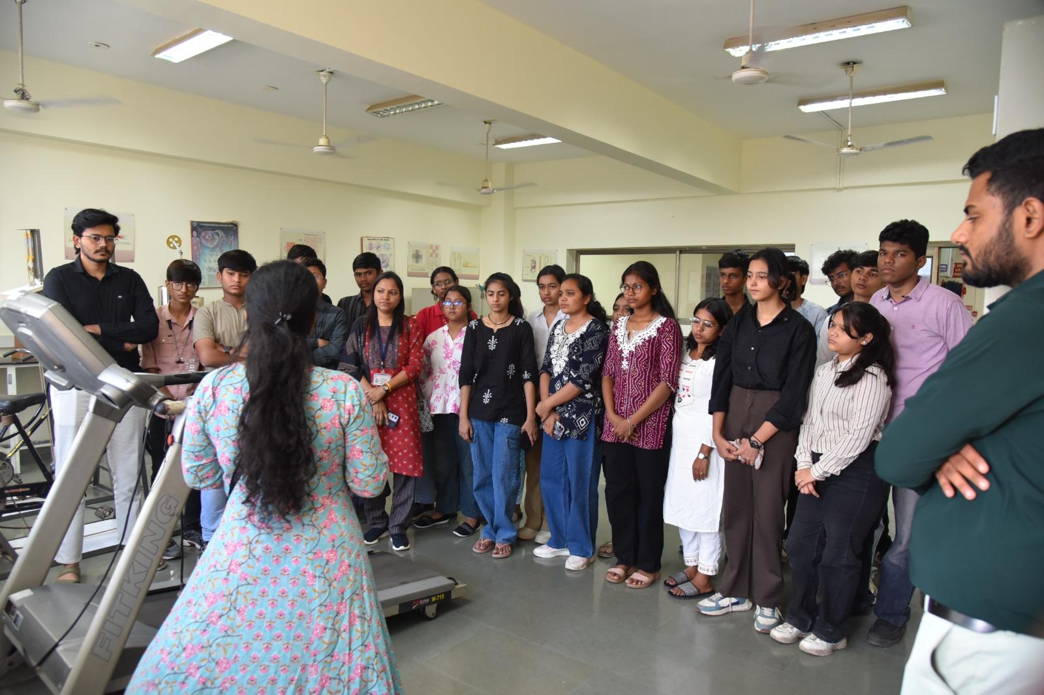
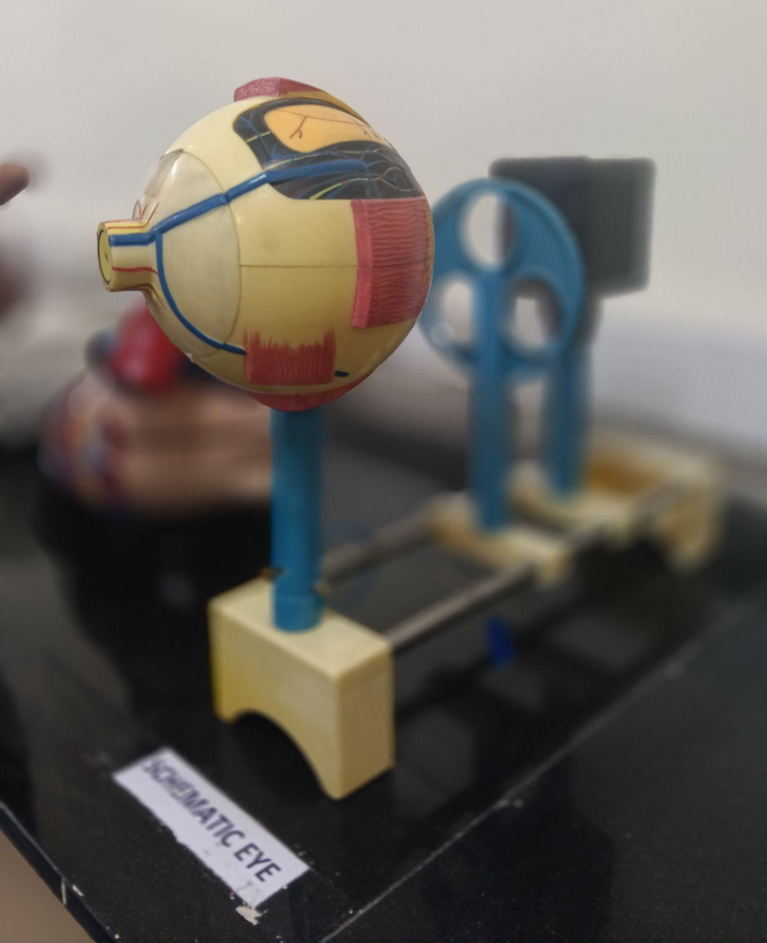 |  |  | 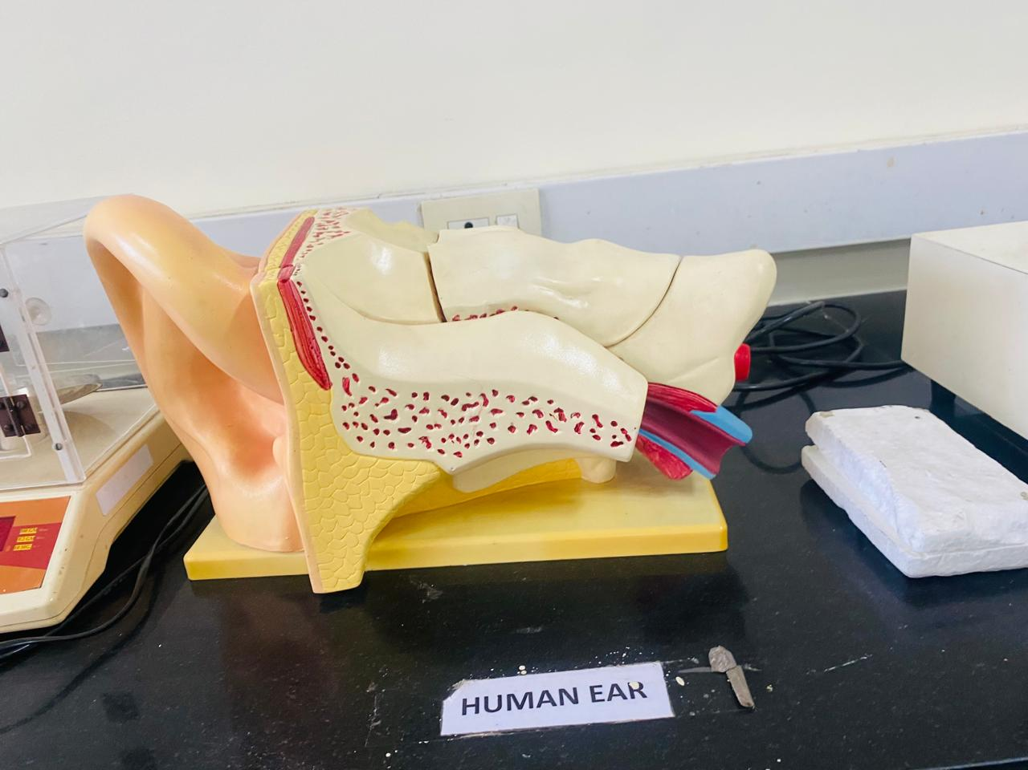 |  | 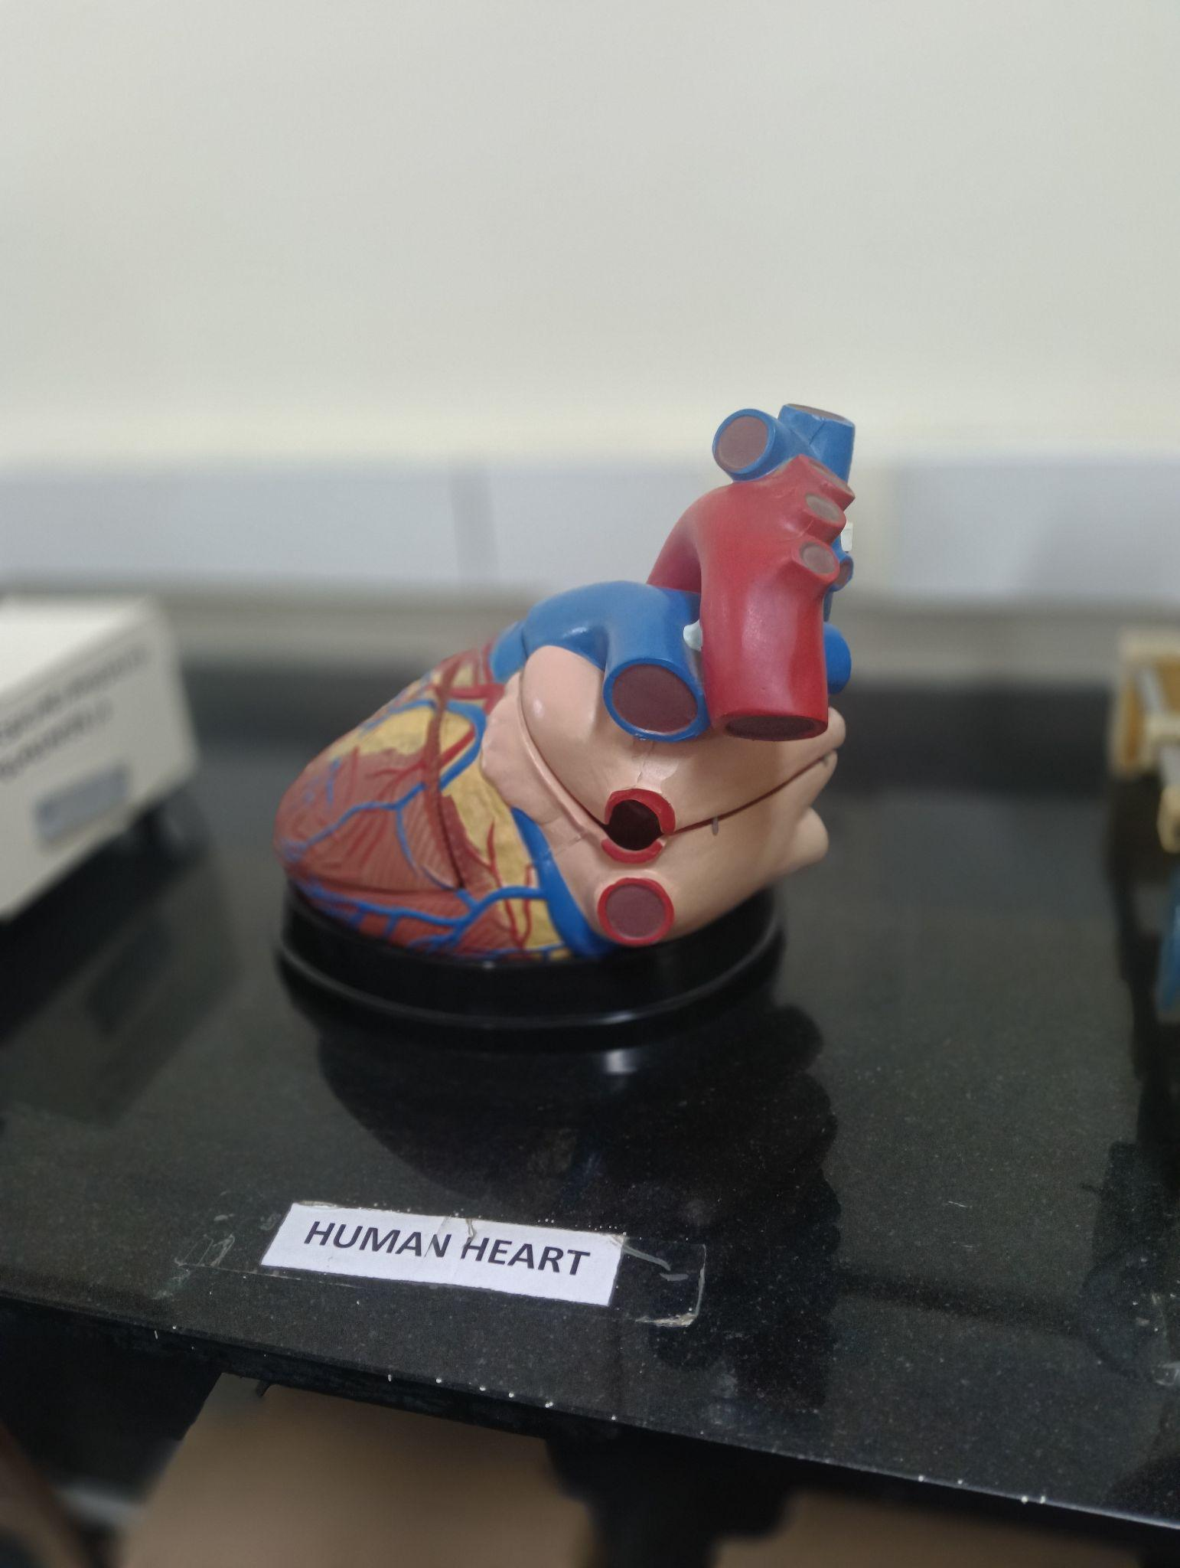
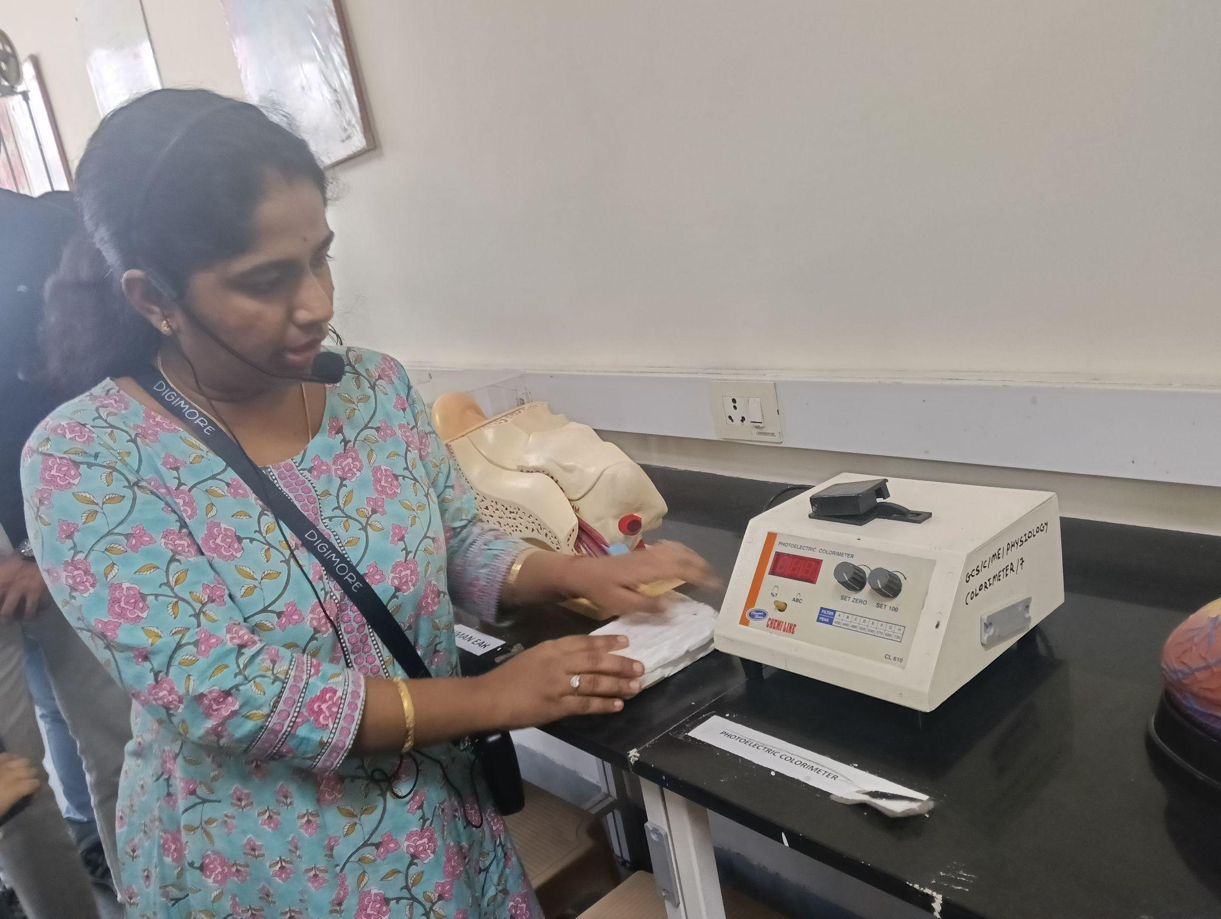 |  |  |  | 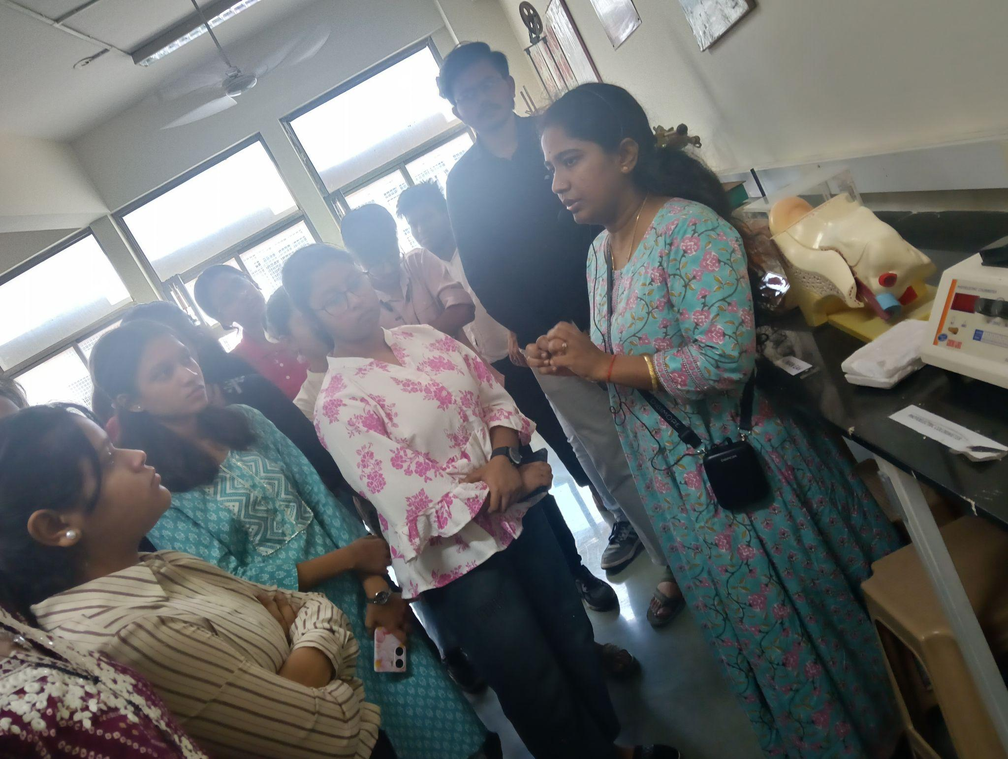
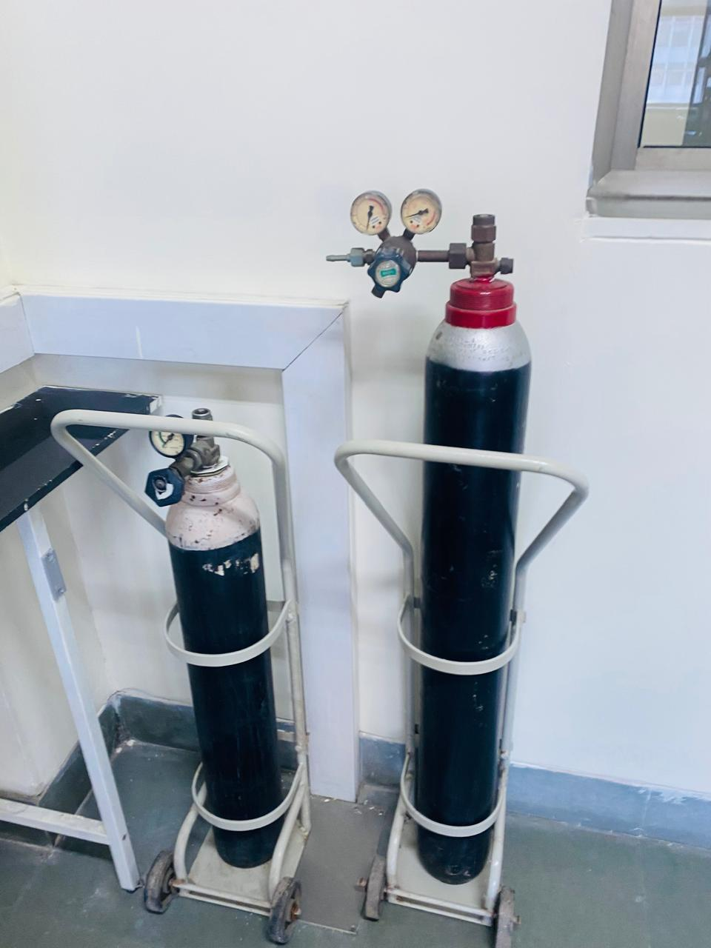 |  |  |  | 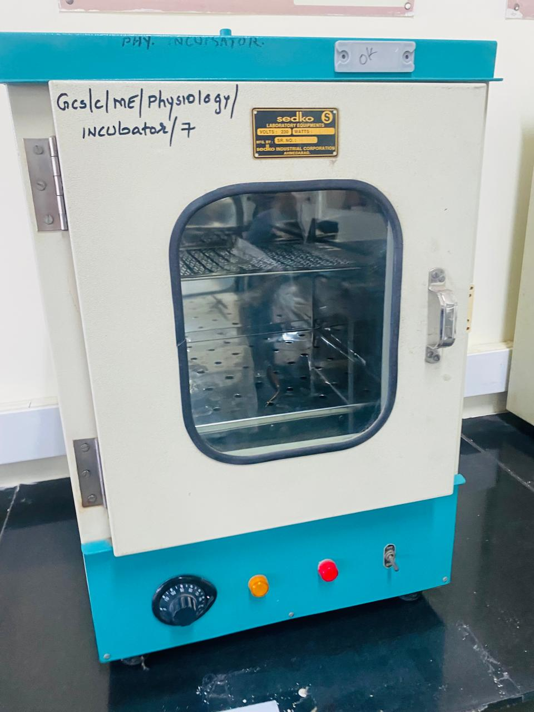
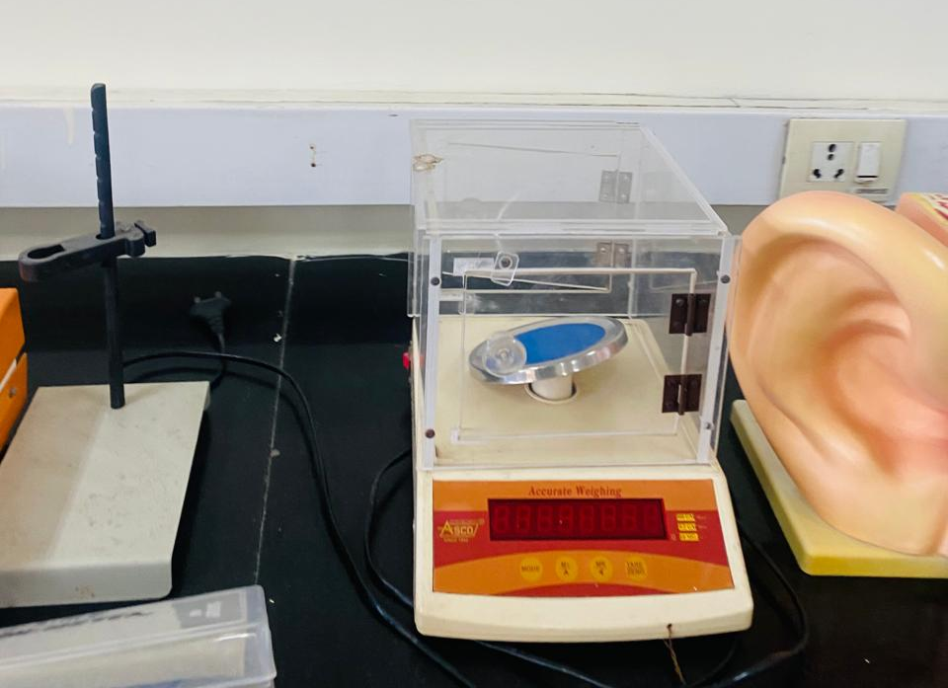 |  |  |  | 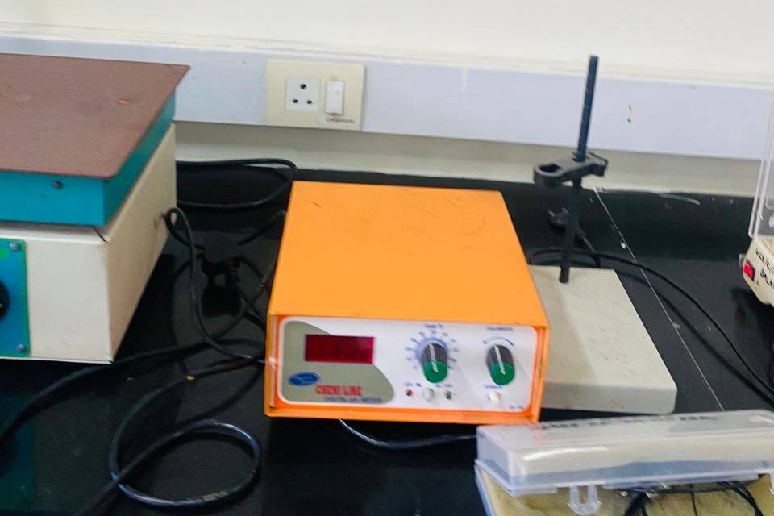
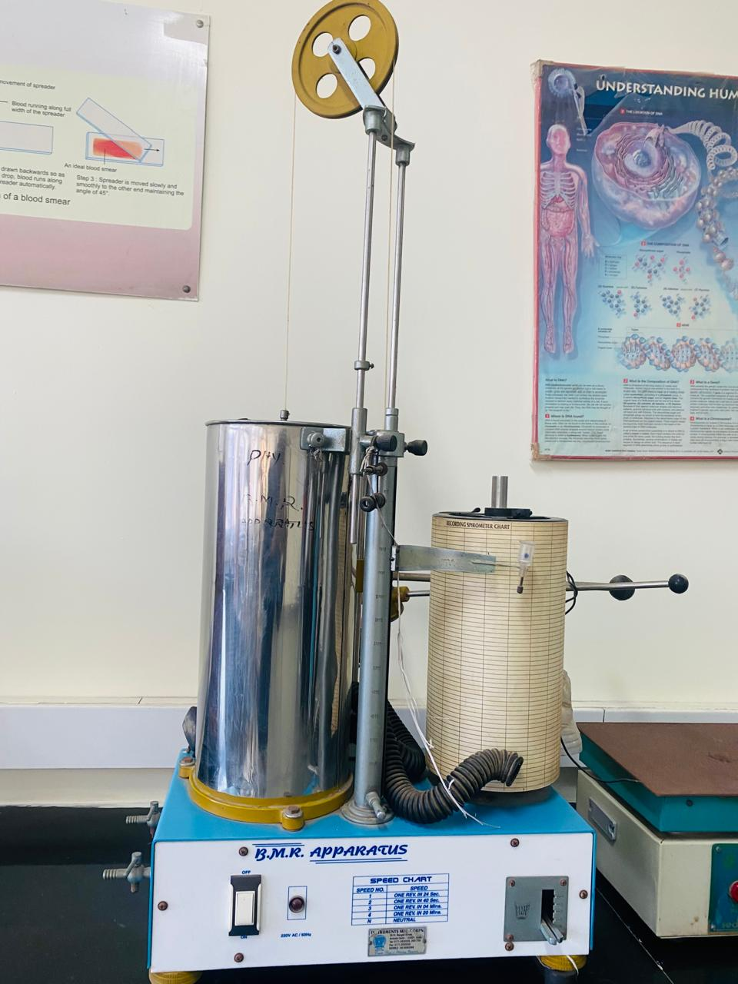 |  |  |  | 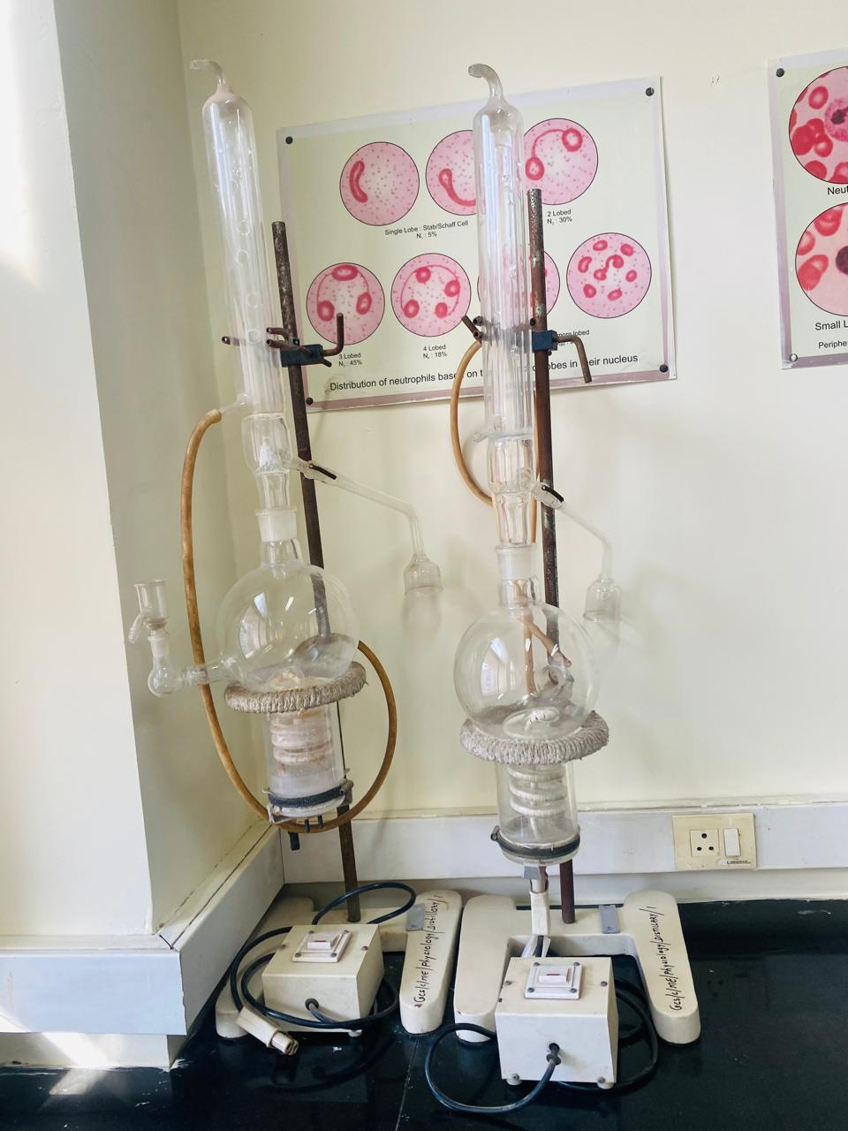
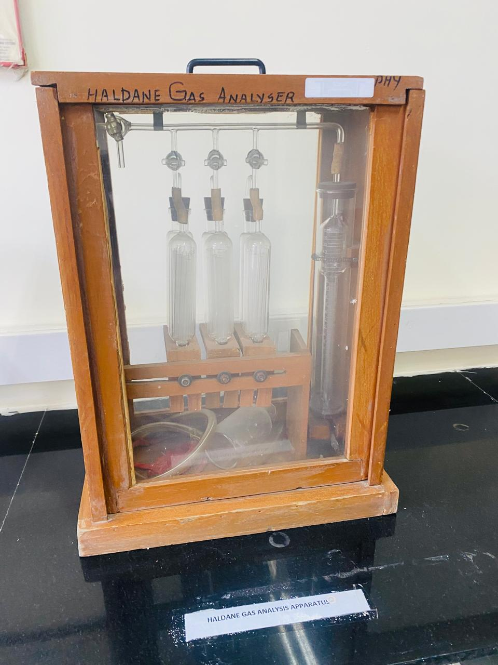 |  |  |  | 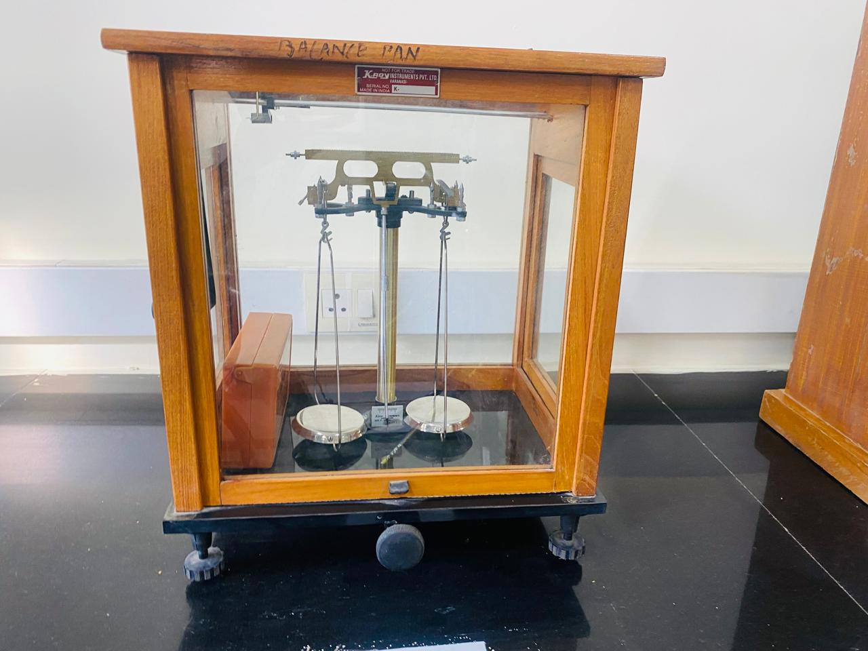

Visit to Physiology Museum

Dr. Ritu then guided the group to the Physiology Museum, which contained an extensive collection of organ models, charts, and labeled structures.

Displayed Models Included:

Heart model – blood flow pathway explained

Kidney model – nephron structure and filtration mechanism

Lung model – alveoli and gas exchange

Brain and pituitary gland models

Charts Demonstrated:

Cell transport mechanisms: diffusion, osmosis, active transport

Pituitary gland functions

Nervous system conduction

Endocrine system regulation

Students observed and understood complex physiological pathways in simplified visual forms.

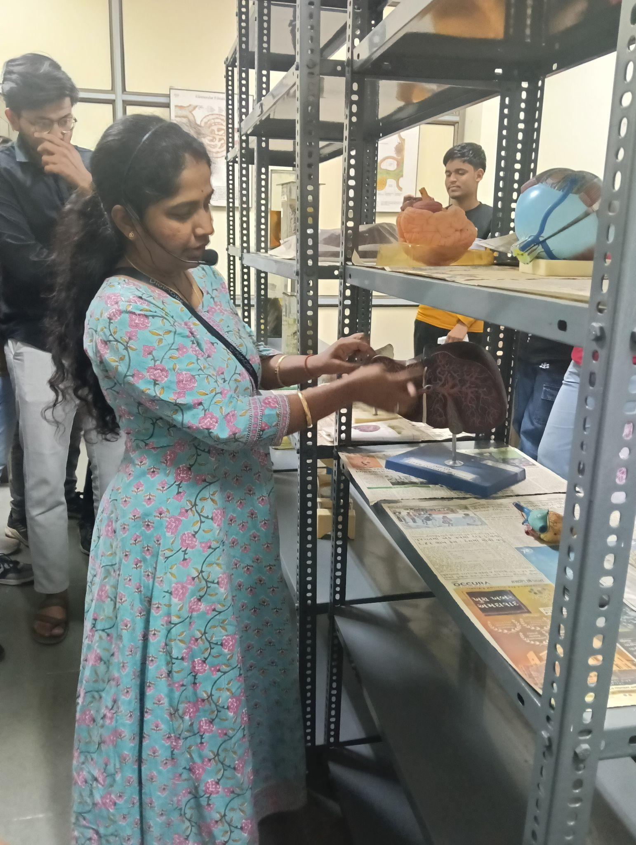 | 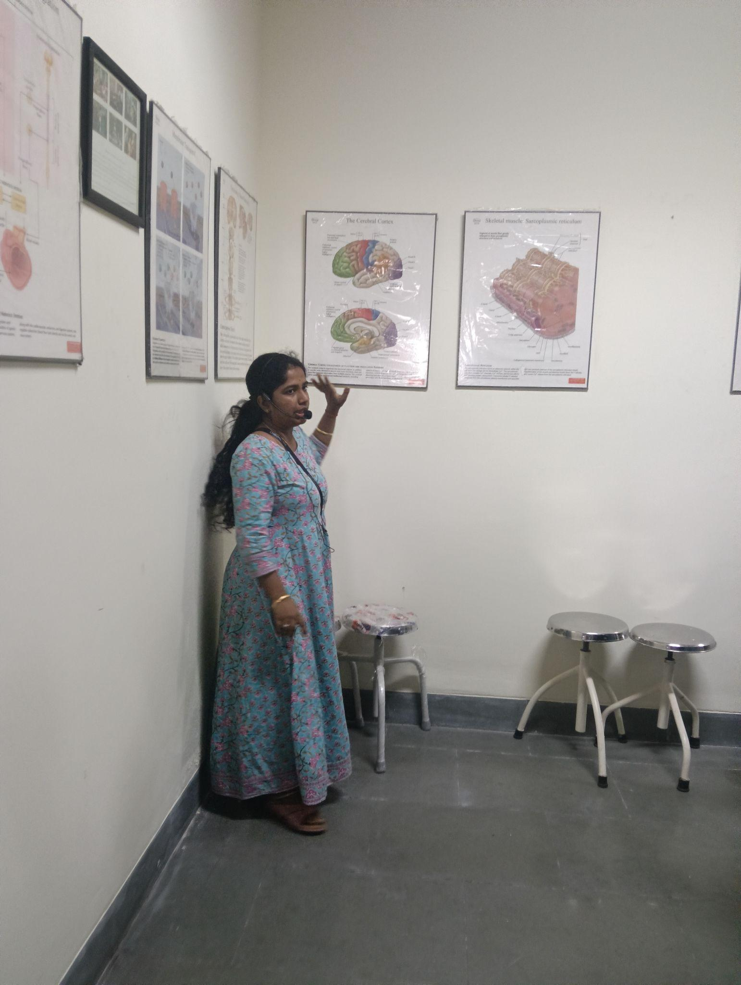
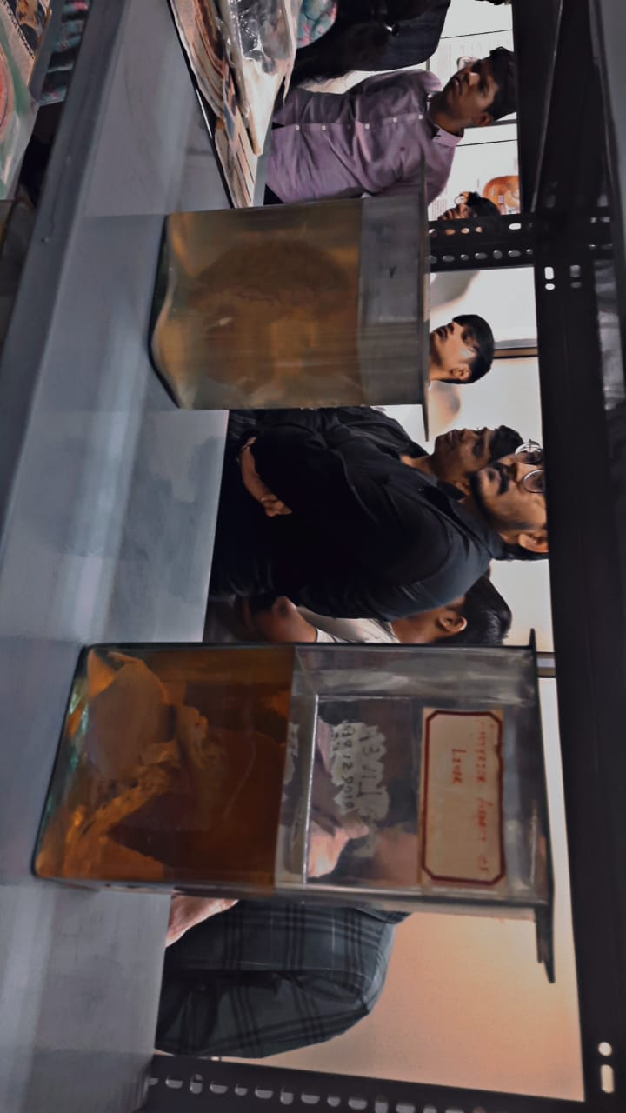
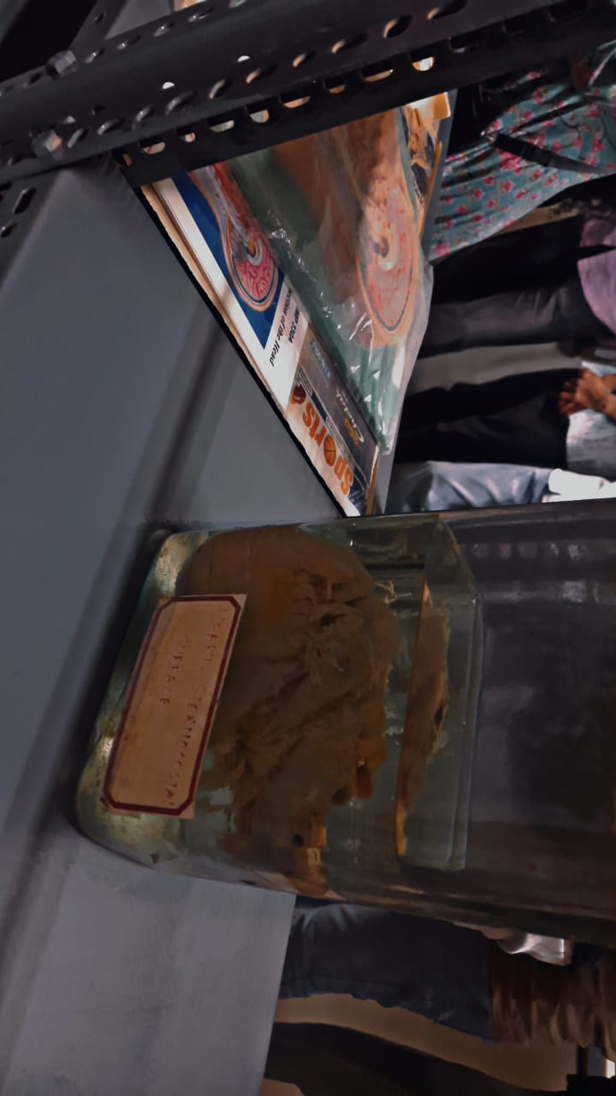
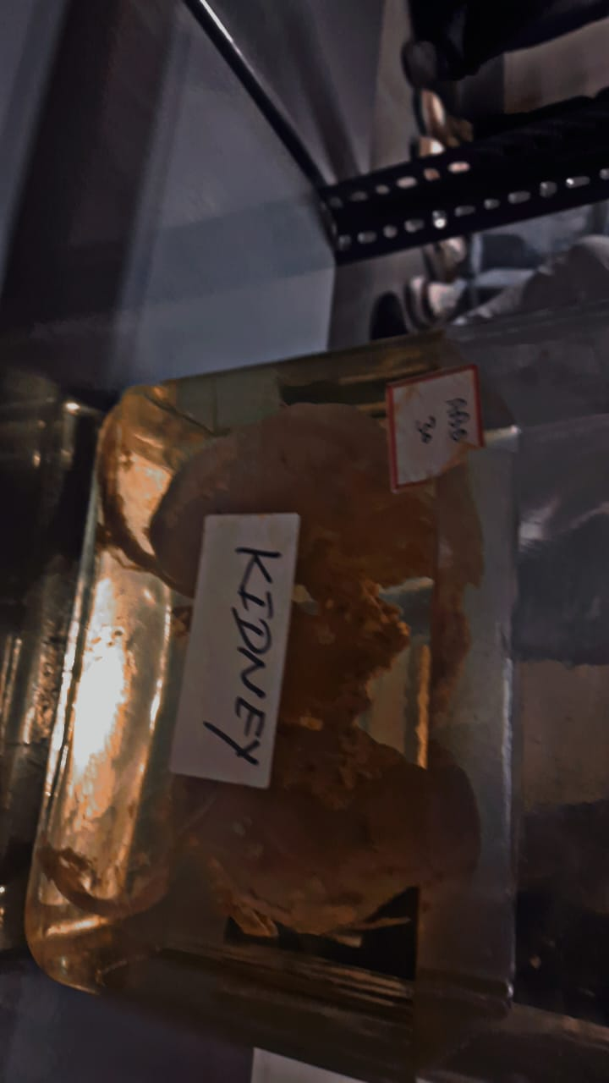

Expert Interactive Session by HOD – Physiology

The final academic session was conducted by Dr. Anand Mistry , Head of the Physiology Department. He delivered an outstanding and detailed lecture covering:

Topics Covered

Physiology of the cell

Action potential – depolarization, repolarization, ion channels

Heart physiology – cardiac cycle, electrical conduction system

Cardiac output – stroke volume, heart rate regulation

Basics of ECG – P wave, QRS complex, T wave

Respiratory system
External respiration – gas exchange between lungs and blood
Internal respiration – gas exchange between blood and tissues
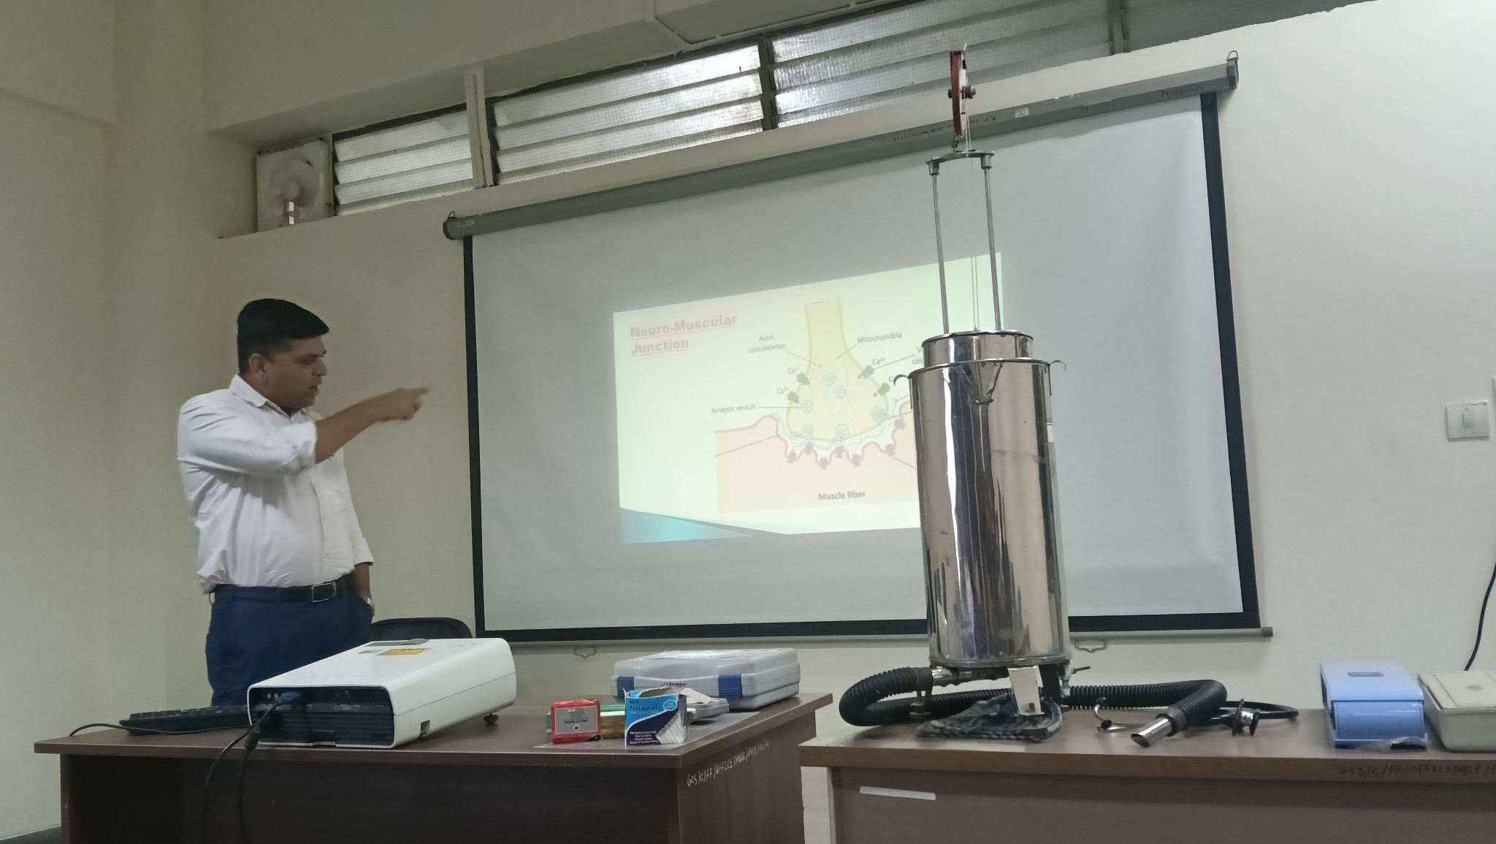
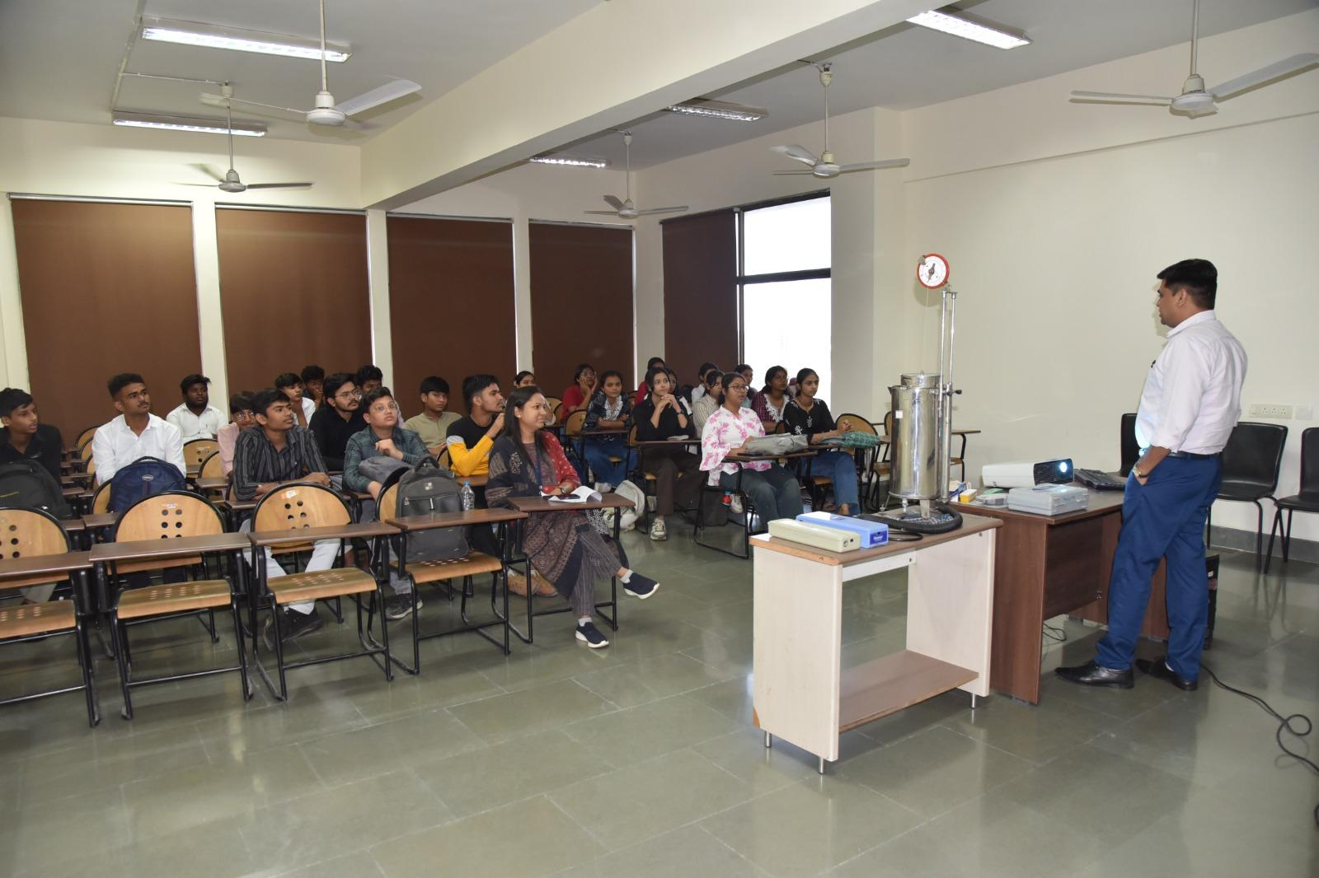
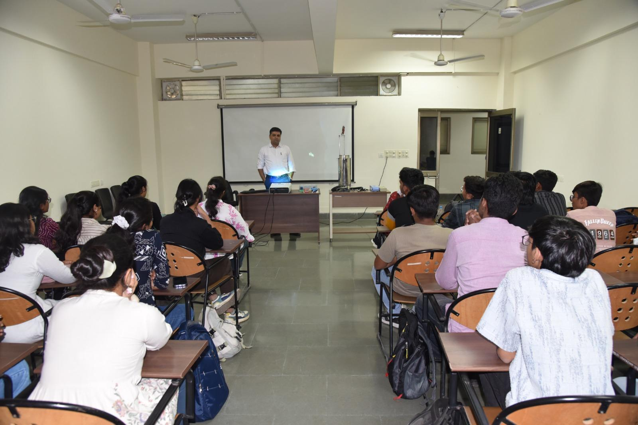

Question–Answer Session

Students actively participated by asking doubts related to:

ECG interpretation

Working of biomedical instruments

Cardiovascular physiology

Lung functioning

The interaction boosted confidence and deepened conceptual clarity.

Refreshments and Conclusion

The hospital management kindly arranged refreshments for all students and faculty members after the session.

The entire visit concluded at 5:20 PM.

Students expressed great interest and enthusiasm throughout the visit. Many mentioned that the experience gave them a deeper appreciation of the mysterious and fascinating world of biomedical science, strengthening their motivation to pursue biomedical engineering with greater dedication.

Overall Learning Outcomes

First-hand exposure to human organs, cadavers, and anatomical structures

Understanding of medical instruments used in diagnostic procedures

Better clarity of cell biology, skeletal system, cardiac physiology, and respiration

Improved connection between textbook knowledge and real medical applications

Enhanced curiosity, confidence, and career motivation

Strengthened professional behavior and interaction with medical experts

Conclusion

The hospital visit to GCS Medical College proved to be a highly educational, inspiring, and memorable experience for all participating students. It successfully achieved the objective of providing real-world exposure to human anatomy and physiology, which forms the foundation for advanced learning in biomedical engineering.
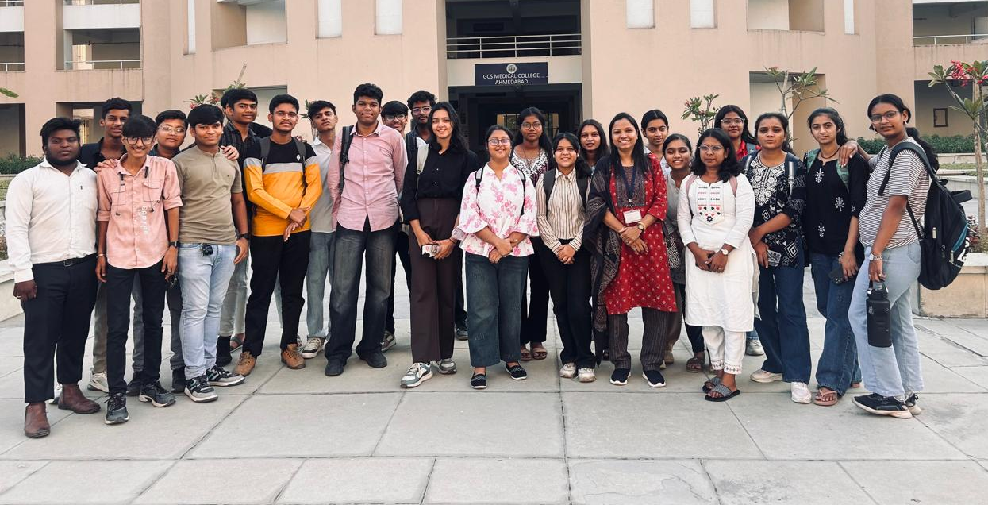
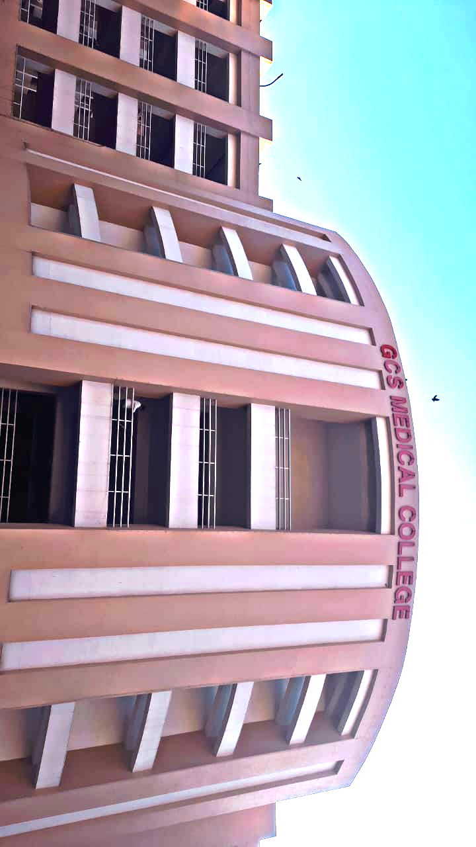
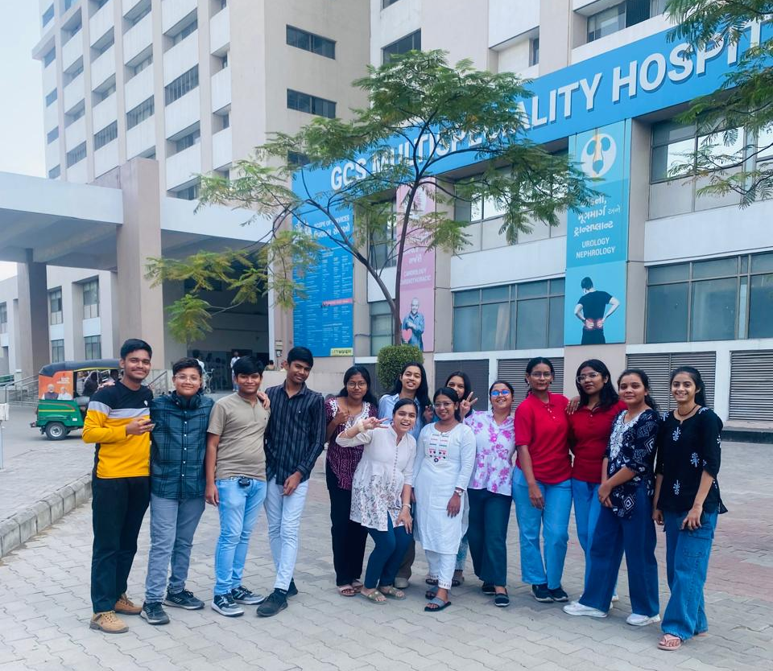
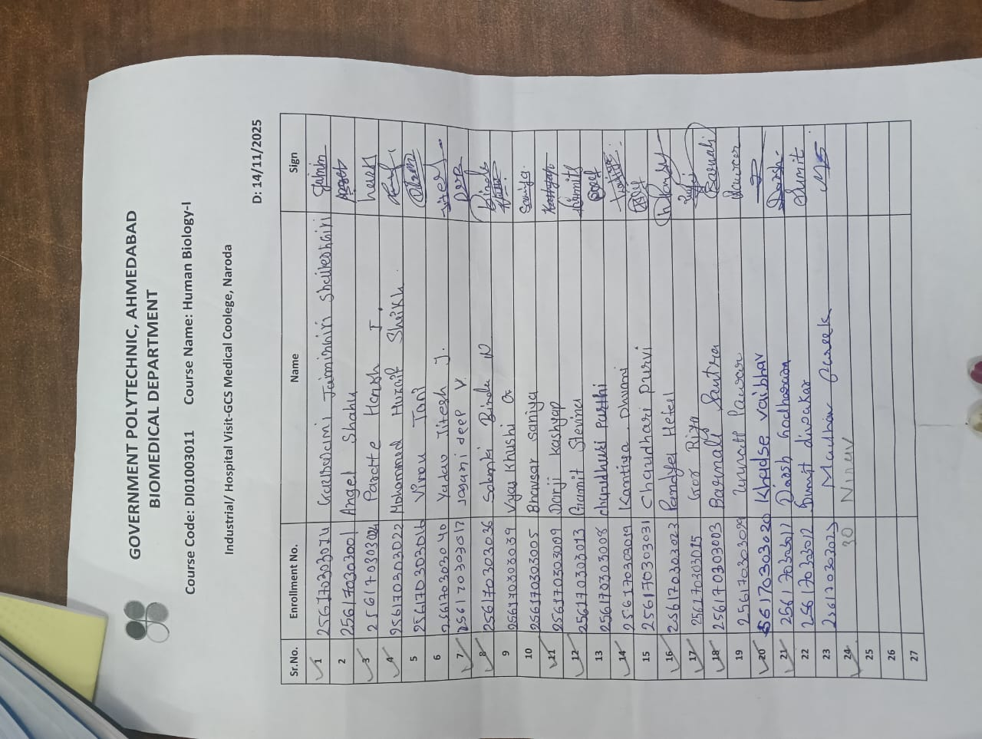
Feedback
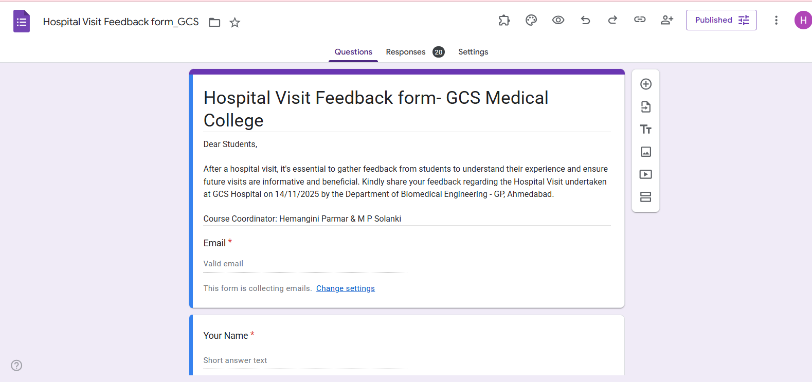
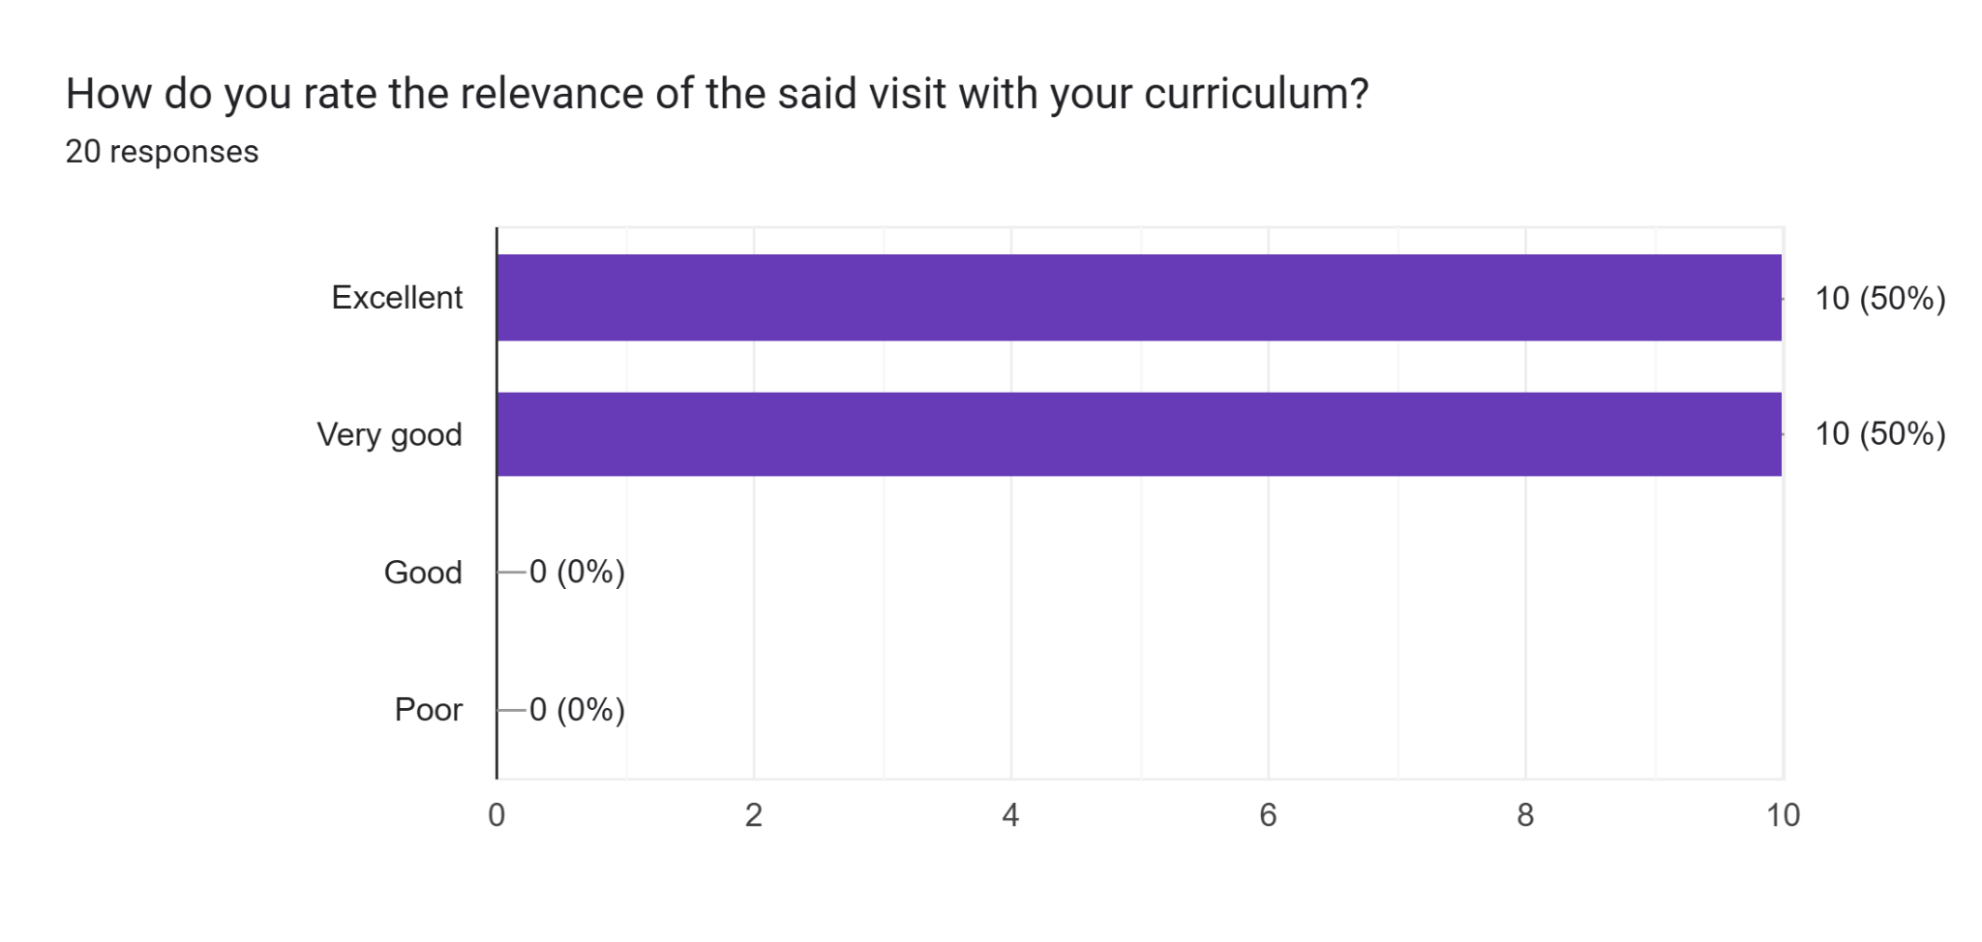
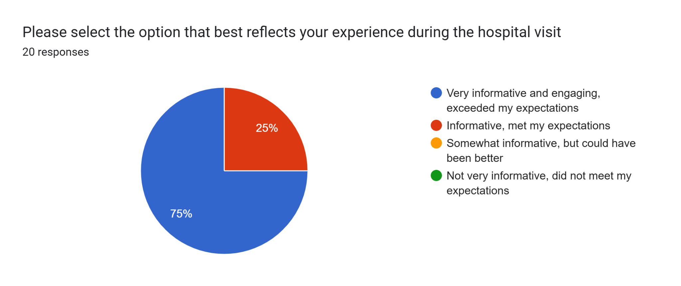
Comments:
I experienced it well and I just loved it
Wonderful college
This was really wonderful.. Please arrange more such visit especially in Biomedical labs & also once in NFSU ( if possible )
Saru hatu
A better experience in my life
“We sincerely thank the GCS Hospital team for providing us with an insightful and well-guided visit today. The detailed explanations, clear responses to all our queries, and the encouraging words shared by the doctors were truly appreciated. This visit added great value to our learning and has inspired us further in our professional journey.”
This visit is very good 👍🏻
Very nice experience
Amazing experience.
I experienced it well and I just loved it i wish I can visit one more time.
Thank you, ma’am, for taking us to the hospital yesterday, and a big thank you to the doctor who taught and explained everything to us in the anatomical department.
Even though it was our first visit, we learned many new things, and everything was explained very clearly.
It was a very good and useful experience for all of us.
Thank you, ma’am, and thank you, doctor.
This visit is best visit and my life one small part
strong academics, good infrastructure, excellent patient exposure, and practically showing things.
All the management team was great at their work and the best thing was seeing real organs for the first time
Had a really good day and ma'am and sir explained things really well
The visit is excellent and very informative
The way they gave us their time and arrangement was amazing and ...! all good
Overall experience was just great for me and also staff was very supportive and teachers also gave their best speech and information

